Horse Permit application
This application is to allow a horse to ride or be lead on a reserve or foreshore reserve. The permit will grant permission from council under section 11.3 Regulation of reserves from the Hobsons Bay Community Local Law 2025.

Applicant Name: __________________________________________
Address: _______________________ State: ___________ Postcode: ______________
Contact Number: ___________________________________
Email: _____________________________________

Conditions of the permit;
- A copy of the permit will be on the handler of the horse during the execution of the permit.
- The use of this permit causes no disturbance to residents.
- The horse will be under control of a handler at all times.
- The horse is not allowed to trot, canter or gallop on the beach.
- The horse is not to be on the foreshore reserve shown below after 9am.
- All horse droppings are to be collected from the reserve/foreshore reserve.
- The horse is to be kept at a distance from congested areas of the beach.
- The use of the beach for the purpose of this permit is entirely at the applicant’s risk.
- The permit is valid for 12 months from the date of issue.
- The fee of $525 has been paid.
I, _______________________ have read and understood the above conditions and agree to abide by all conditions of this permit.
If any permit conditions are not adhered to, the permit may be considered for cancellation and/or enforcement action may be taken.
Signed: _____________ Dated: ______________

The foreshore area allowed for this permit is the Burns P.A. Reserve in Altona VIC 3018
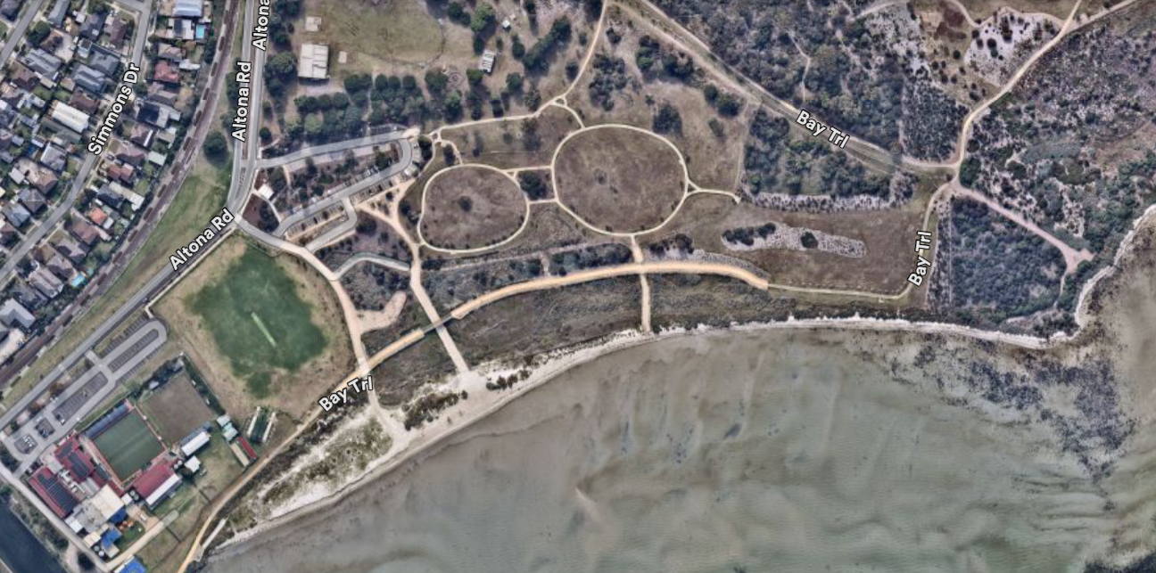

If the permit is needed for an alternative location, permission will need to be requested via an email to Animalmangement@hobsonsbay.vic.gov.au for our team to review the location and assess suitability.

