Return to:

Kindergarten Access Officer

Hobsons Bay City Council

P.O. Box 21

ALTONA 3018

# Hobsons Bay Four Year Old Kindergartens

# Change of Preference/Change of Address Form

Surname: .......................... Child’s given name: …..….……….. Date of birth: ..........................

Old address: .........................................................................................................................…..

…………………….….......................... Old phone number: ..…………………….….…………….

Year to attend four year kindergarten: ..………………………………..………...

What was your original preference? ………………………………………..…….(required)

## Changes to original details

New address (if applicable): ......................................................................................................

New telephone number (if applicable):.......................................................................................

New preferences for kindergarten

1. 2……………………………………...

3. 4……………………………………...

5.

Any other changes to original details: …………........................................................................

Name of parent/guardian (please print): …………....................................................................

Signature of parent/guardian: …………...........................................

**KE.3**

Date: .................................

***PRIVACY COLLECTION STATEMENT*** *– Hobsons Bay City Council*

*is committed to protecting your privacy. The information you have 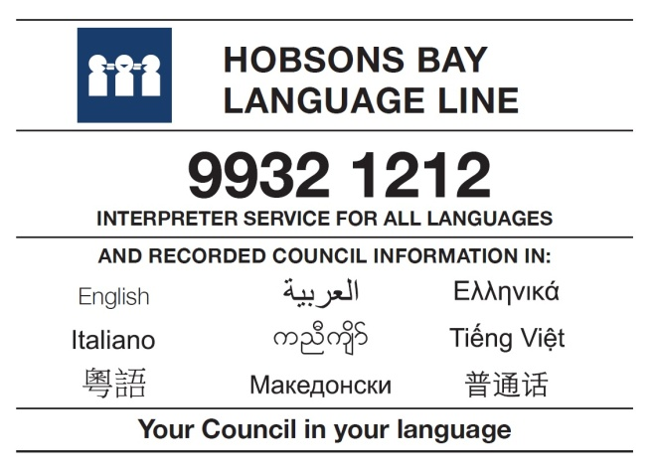*

*supplied on this form will be used by Council to update your personal*

*details in our system and/or your change of kindergarten preference.*

*Your personal information and the personal information regarding your*

*child will not be disclosed to any external party without your consent,*

*unless required or authorised by law.  You have a right to access and*

*make corrections to the personal information supplied on this application.*

*If you have any queries or wish to gain access to amend your information*

*please contact Council’s Kindergarten Enrolment Officer on 9932 1162*