Return to:
Kindergarten Access Officer
Hobsons Bay City Council
P.O. Box 21
ALTONA 3018

Hobsons Bay Four Year Old Kindergarten
Cancellation Advice Form

I ......................................................wish to withdraw my child......................................................

Address: .......................................................................................................................................

From: .................................................... Kindergarten

Parent’s signature: .........................................................................

Date: .........................................................

Teacher’s signature: ......................................................................

Date: ……………………………………………………

PRIVACY COLLECTION STATEMENT – Hobsons Bay City Council is committed to protecting your privacy. The personal information you have supplied on this form will be used by Council to act on your advice that you wish to withdraw your child from a Hobsons Bay Four Year Old Kindergarten program. Your personal information and the personal information regarding your child will not be disclosed to any external party without your consent, unless required or authorised by law. You have a right to access and make corrections to the personal information supplied on this application. If you have any queries or wish to gain access to amend your information please contact Council’s Kindergarten Enrolment Officer on 9932 1162.
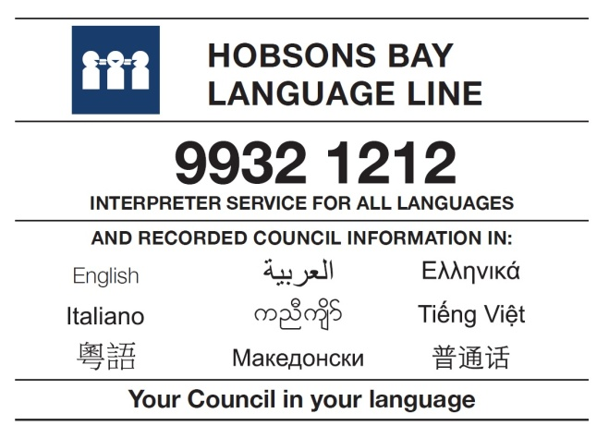
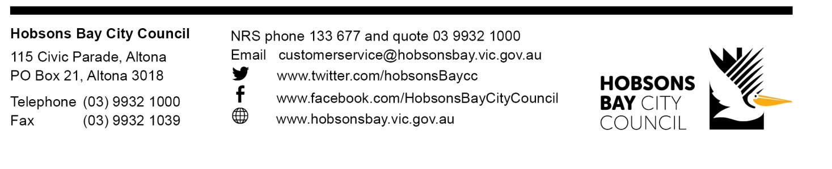
KE.4

