Help to pay your bills
Easy English
You can ask for help if you
- live in Hobsons Bay and
- cannot pay the bills on your house or business

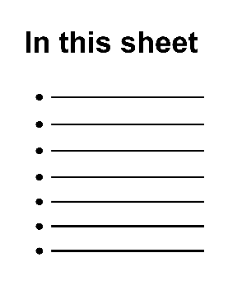
This sheet is about
- who can ask for help
- what bills you can get help with
- how to ask for help
- where else you can get help.
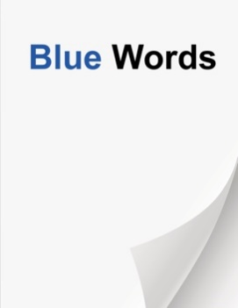
Some words in this sheet are blue. You can find out the meaning of these words at the end of this sheet.

Who can ask for help?
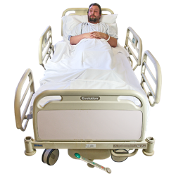
You might find it hard to pay bills for different reasons. For example
- you have lost your job
- you cannot work because you are sick
- there have been changes in your family
- your partner has died
- you have less or no money coming in
- COVID-19.

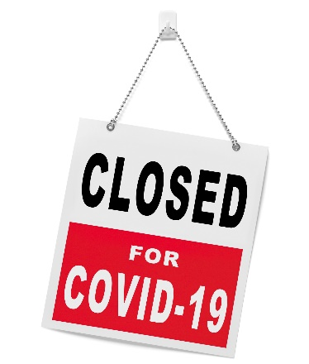
You can also ask for help if you are part of a
- business
- sports club
- community group
and cannot pay the bills.

What bills can you get
help with?
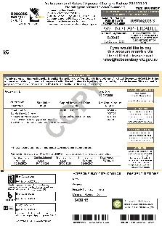
You can ask for help with bills including
- Council rates
- rent on Council buildings
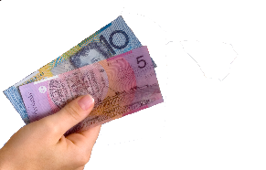
- interest on rates or Council fees you owe

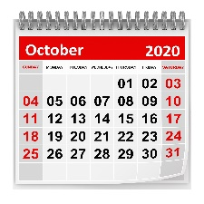
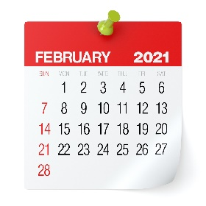
The help can include
- moving the due date. This means you can pay later.
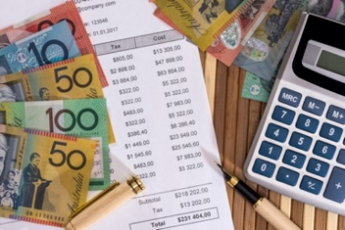
- a payment plan. This means you pay smaller amounts for a longer time.

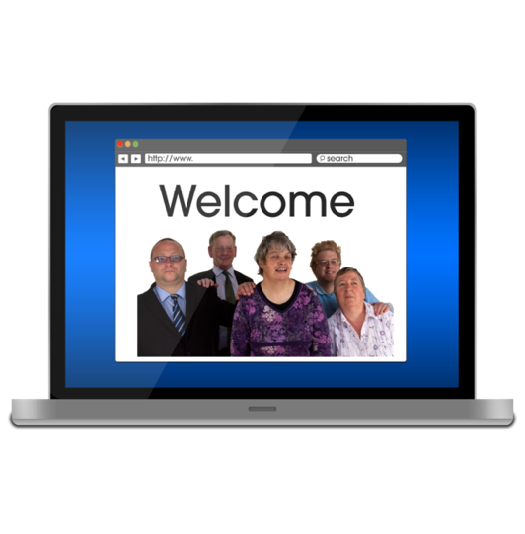
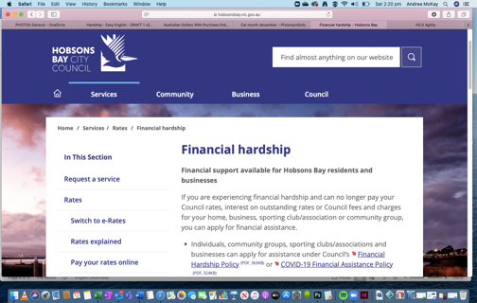
How to ask for help
If you want to ask for help with your bills you need to fill out a form. The form is called the
Request for Financial Assistance Application.
You can get the form on our website.
Go to www.hobsonsbay.vic.gov.au/financialassistance

You can ask for help to fill out the form.
Phone: 1300 179 944

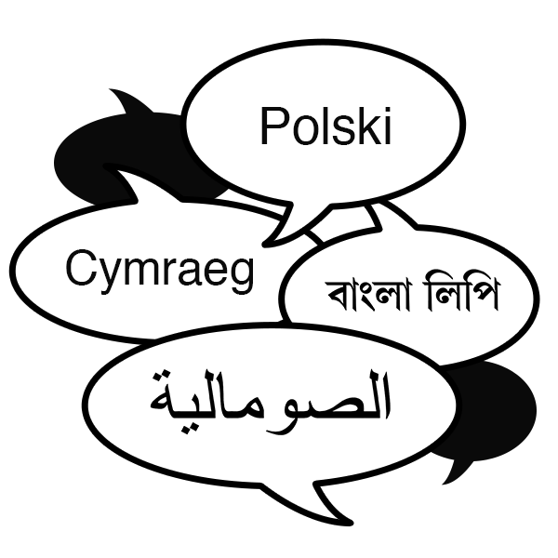
中文
Tiếng Việt
You ask for help in your first language.
Phone 9932 1212.
You can also get this sheet in different languages.
Go to www.hobsonsbay.vic.gov.au/financialassistance
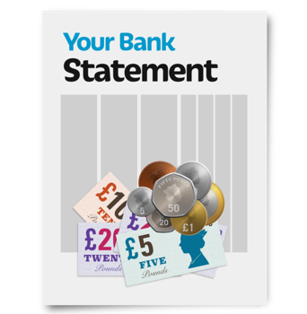

When you fill in the form you will need to give us some other information. For example
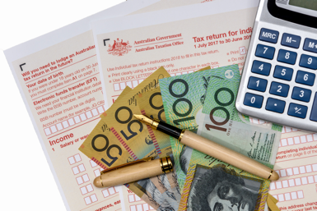
- bank statements
- Centrelink information
- tax information.

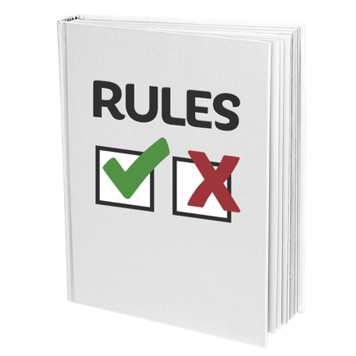
After you give us your form and information we will decide if you can get help with your bills.
There are rules we must follow when we decide. These are called the
- Financial Hardship Policy
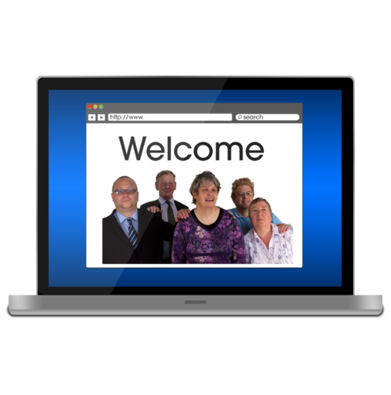
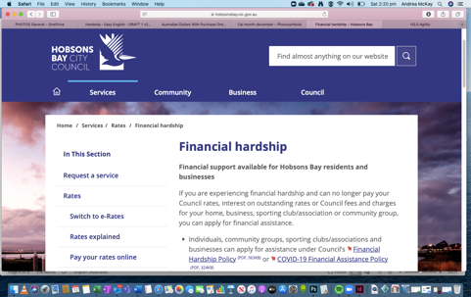
- COVID-19 Financial Assistance Policy
You can read these policies on our website
Go to: www.hobsonsbay.vic.gov.au/financialassistance
or you can ask us for a copy.
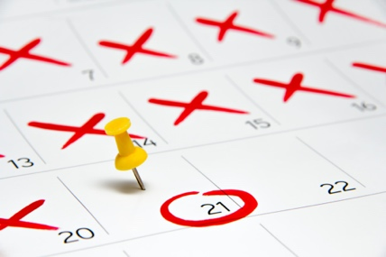
We will tell you our decision within 21 days. We will do this in writing.

Where else can you get help?
If you need help to manage your money you can speak to someone at
Financial and Consumer Rights Council
of Victoria
They can help you find someone to tell you how to manage your money.
Phone 9663 2000
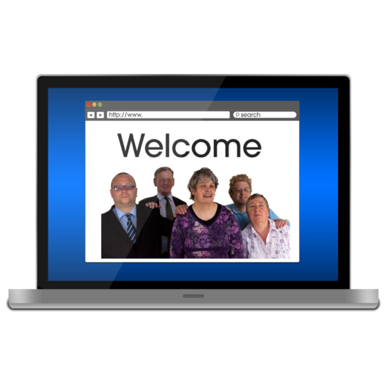
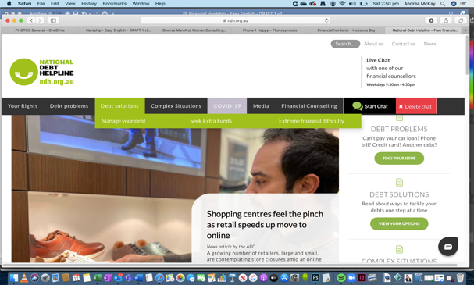
Go to www.fcrc.org.au

National Debt Helpline
They can help you manage your money if you owe money.
Phone 1800 007 007
Go to www.ndh.org.au

What do these words mean?
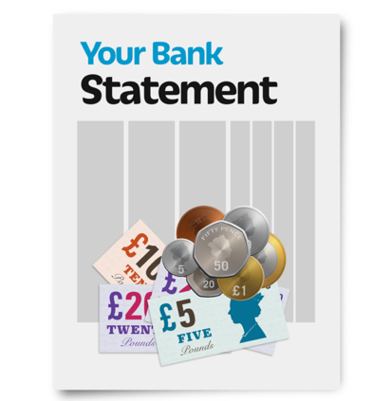 | bank statement  A letter or document you get from the bank each month that says how much money you have and what you have spent.
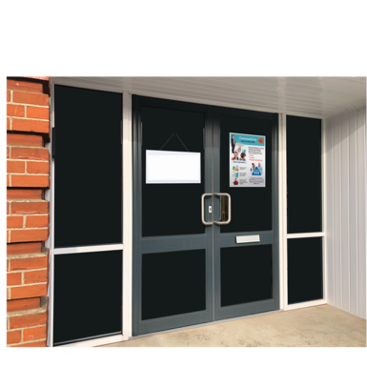 | business  A place where people work and earn money. For example  - a shop or cafe  - a service  - an office.
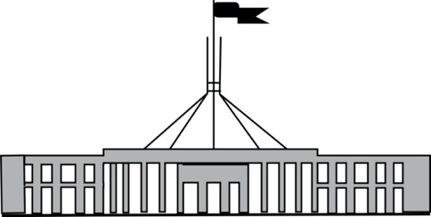 | Centrelink  A part of the Government that provides payments to people who cannot work or have a low income.

community group
Groups that provide support or bring people together in the community. For example
- neighbourhood houses
- church groups
- sports clubs
COVID-19
A new illness that that is making people very sick all around the world.

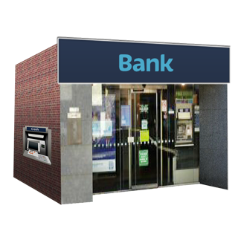 | fees and charges  Money you pay to a business to provide you with a service. For example when a bank gives you a loan you may have to pay a monthly fee or a fee to set up the loan.

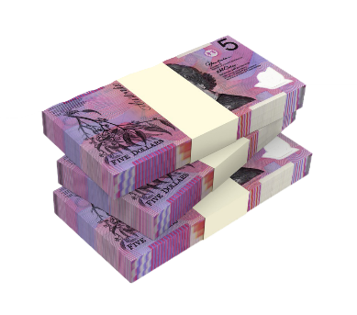
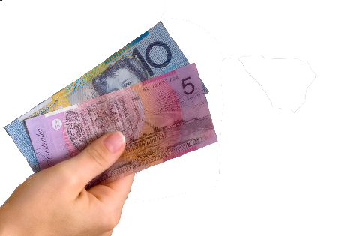
interest
Extra money you pay to the bank each month as part of your loan. For example when you have a loan the bank will charge you
- a monthly repayment amount
plus
- some interest.
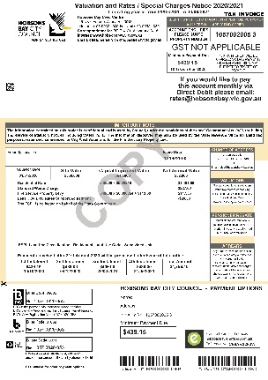 | rates  Money you pay to the Council so they can provide local services. For example  - your bin collection  - local roads  - local parks and libraries.
rent
Money you pay to
- live in your house
- use a building for your business
when someone else owns it.

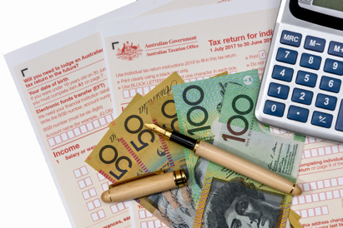 | tax  Money you pay to the government so they can provide things like  - schools  - hospitals  - roads  - police  - fire brigades.

The Easy English on this sheet is written by Clear Words and Hobsons Bay Council. www.clearwords.com.au

Images in this book are from
Photosymbols. www.photosymbols.com
IStock. www.istock.com

You can print this book. If you want to copy or use images from this book you must ask us first.

