
Neighbourhood Profile

Williamstown

First published by Hobsons Bay City Council October 2009

NB: The data profile was updated in 2016 and includes 2011 census data. Other sections in the profile have not been updated.

Table of Contents

Executive Summary 1

Past, Current and Future Development 3
A. Introduction 4
B. History & Development 4
Aboriginal History 4
European Settlement 5
More recent developments 6
C. The Current Environment 7
Land uses 7
Natural features and parks 9
Residential development 9
Community library, centres and halls 10
Children’s services 11
Schools 12
Recreational facilities and open space 13
Cultural Activities 15
Retail Centres 15
Medical Centres 15
Dentists 16
Pharmacies 16
Public transport 17
References 17

Data Profile 19
A. Population Characteristics 19
Population: number and age structure 19
Family and household types 20
Cultural diversity of residents 21
People with a disability 22
Participation in education 24
Internet access 26
B. Labour Force Characteristics 27
Labour force participation 27
Employment by industry 28
Unpaid work and volunteering 30
C. Financial Wellbeing 32
Individual incomes 32
Household incomes 33
Centrelink payments 35
SEIFA index of disadvantage 35
Gambling losses 35
D. Housing 37
Dwelling types 37
Public housing stock 37
Residential aged care 37
Building permits 38
Housing tenure 38
The cost of housing 38
Housing mortgages 40
Housing stress 41
E. Transport 42
Car ownership 42
Journey to work 42
F. Population Forecasts 44
Population numbers 44
Housing and household forecasts 45

Consultations 48
- Introduction 48
B. Methodology 48
C. Findings 48

Tables and Graphs
Table 1: Population and age structure 19
Table 2: Families with children 20
Table 3: Households without children 21
Table 4: Overseas born residents 21
Table 5: Country of birth for residents born overseas 22
Table 6: Year of arrival in Australia of overseas born residents 22
Table 7: Residents who need assistance with a core activity 23
Table 8: Participation in education (persons aged 15 years and over) 24
Table 9: Highest level of schooling completed (persons aged 15 years and over) 25
Table 10: Highest qualification 25
Table 11: Households with internet connection 26
Table 12: Labour force participation 27
Table 13: Employment status 27
Table 14: Industry sector of employment 28
Table 15: Occupation 29
Table 16: Volunteer status (aged 15 years and over) 30
Table 17: Unpaid child care (aged 15 years and over) 30
Table 18: Unpaid assistance 31
Table 19: Gross weekly income individual income (persons aged 15 years and over) 32
Table 20: SEIFA index of disadvantage ranking (2011) within Hobsons Bay 35
Table 21: Private dwelling types 37
Table 22: Public housing stock by bedroom number in Williamstown 37
Table 23: Type of public housing in Williamston 37
Table 24: Housing tenure of households (occupied dwellings) 38
Table 25: Car ownership 42
Table 26: Main method of travel to work 43
Table 27: Population forecasts 44
Table 28: Future housing and households 45

Graph 1: Population change between 2016-11...................................................................................19
Graph 2: Age structure of Williamstown and Hobsons Bay 20
Graph 3: Changing in need for assistance for Williamstown residents 24
Graph 4: Individual income quartiles (persons aged 15+) 33
Graph 5: Household Income (weekly) for Williamstown 34
Graph 5: Household income quartiles for Williamstown 34
Graph 6: Trend data - Median house and unit prices 39
Figure 7: Houses – purchase and rental in Williamstown 39
Figure 8: Units – purchase and rental for Williamstown 39
Graph 9: Monthly housing loan repayments (households) 40
Graph 10: Loan repayment quartiles 41
Graph 11: Forecast age structure 44
Graph 12: Changes in age structure between 2015-2025 45
Graph 13: Change in household types between 2015 and 2025 46

Williamstown Neighbourhood Profile
Executive Summary

The Williamstown neighbourhood begins at Yarra Street, to the north, and is bordered by Port Phillip Bay along the southern and eastern boundaries. To the west and on the north side of Ferguson Street, the boundary is formed by the railway line and then links to Bayview Street via Kororoit Creek Road. (NB: Williamstown neighbourhood, as referred to in this profile, differs from the suburb of Williamstown; it does not include the area on the south side of Kororoit Creek Road, commonly called the Rifle Range.)

The Williamstown neighbourhood is predominantly residential and has some small pockets of light industrial areas. Large parts of the neighbourhood are covered by heritage controls and the neighbourhood has many examples of significant buildings from the 1800s. The coastline is a dominant aspect of the Williamstown neighbourhood. Shipping construction and boating activities are also features and the area’s maritime history remains clearly evident.

Residents speak positively about living in the neighbourhood. “I look out of my house and see water which gives Williamstown a sense of isolation and a village feel” and “It’s a mix of being a country town and a seaside town. It’s a place that you want your kids to grow up in and the proximity to the beach gives it a holiday feel.” There is a strong sense of attachment to the area but acknowledgement that the area is changing, “When I first arrived it was definitely more working class, but that’s changed”. People are concerned that the character of Williamstown is protected, commenting “I want it to keep its seaside feel – smaller and simpler – not like a millionaires’ row, not like the St Kilda marina”.

Population numbers
- At the 2011 Census, Williamstown had a population of almost 10,600 people (12% of the municipality’s residents), and an increase of 420 residents since 2006.
- Population forecasts anticipate numbers will increase to just over 13,000 by 2020, after which time growth is expected to flatten out, reaching 13,648 by 2025.

Age structure
- Between 2006 and 2011, the number of young and school aged children increased, as did the number of 18-24 year olds. Alongside this trend was a decrease in younger adults aged 25-34.
- Among the older age groups, the main change was an increase in adults in the 50-69 age bracket.
- Between 2015 and 2025, all age groups are forecast to increase except for those aged 85 years and over.

Overseas born residents
- Approximately 21 per cent (2,190) of Williamstown residents were born overseas, well below the municipal rate of 31 per cent. The main countries of birth were the United Kingdom and New Zealand.

Residents needing assistance
- Estimates suggest that approximately 1,800 residents living in Williamstown have a disability.
- At the 2011 Census, there were 428 residents who required assistance with core activities involving self care, communication and mobility.

Education
- Just over 25 per cent of people in Williamstown were enrolled in education at the 2011 Census, marginally higher than the Hobsons Bay rate of 22 per cent.
- Just over 60 per cent of those aged 15 years and over have completed secondary school or a Year 12 equivalent, compared to the municipal figure of 50 per cent.

Labour Force
- Williamstown’s labour force participation rate (65%) was above the Hobsons Bay figure (61%). At the 2011 Census, Williamstown’s unemployment rate was 3.7 per cent, below the Hobsons Bay figure of 5.6 per cent.
- Among those who are employed, 60 per cent work full time and 35 per cent work part time. Compared to Hobsons Bay, the proportion of part time workers is approximately four per cent higher.
- The main industries to employ Williamstown’s residents are professional, scientific and technical services, education and training and health care and social assistance.

Income
- According to the 2011 Census, approximately 53 per cent the Williamstown population aged over 15 years have gross weekly incomes below the Victorian average income of around $976, compared to the Hobsons Bay figure of 65 per cent.
- Around 24 per cent of Williamstown’s residents earned $1,500 or more per week, compared to 14 per cent of the Hobsons Bay population. Those with very low incomes (below $400 per week), accounted for 31 per cent of Williamstown’s residents, below the municipal rate of 37 per cent.

Housing
- In 2011, there were 4,656 dwellings in Williamstown. Sixty two per cent of these were detached houses (ie single dwelling on a single lot), around 13 per cent less than the municipal rate.
- Approximately 34 per cent of households are home owners, 32 per cent have a mortgage and 29 per cent are renters. The neighbourhood also has the largest supply of public housing in the municipality.
- Since the 2006 Census, home ownership in Williamstown has remained at around 34 per cent, two per cent higher than home purchasing. The percentage of renters also remained steady at 29 per cent.

Transport
- Williamstown has access to both train and bus services.
- A slightly higher proportion of Williamstown households do not own a vehicle (Williamstown 11%; and Hobsons Bay 9%).
- Approximately 47 per cent of households own more than one vehicle, similar to the Hobsons Bay rate.

DISCLAIMER
Every care has been taken to ensure the information in this document is correct. However, Hobsons Bay City Council does not accept any liability to any person or organisation for the information (or the use of such information) provided in this document.

Williamstown Neighbourhood
Past, Current and Future Development

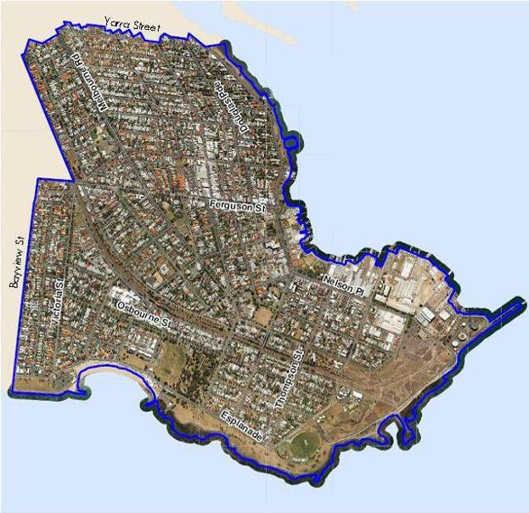

A. Introduction

The Williamstown neighbourhood begins at Yarra Street, to the north, and is bordered by Port Phillip Bay along the southern and eastern boundaries. To the west, the boundary is formed by the railway line, on the north side of Ferguson Street, which then links to Bayview Street via Kororoit Creek Road. (NB: Williamstown neighbourhood, as referred to in this profile, differs from the suburb of Williamstown; it does not include the area commonly called the Rifle Range.)

The Williamstown neighbourhood is predominantly residential and has some small pockets of light industrial areas. Large parts of the neighbourhood are covered by heritage controls and the neighbourhood has many examples of significant buildings from the 1800s. Along the coastline, which is a dominant feature of the Williamstown neighbourhood, is a long ribbon of coast, edged with expanses of open space. Shipping construction and boating activities are important features and the area’s maritime history remains clearly evident.

The Williamstown Botanic Gardens are located just east of the swimming beach, and are one of the earliest botanic gardens to be established in Victoria. The area has a public hospital, three primary schools and a senior secondary college. A public library is also located here and transport options include a train service to central Melbourne and several bus services to neighbouring suburbs and beyond.

B. History & Development

Aboriginal History
Before European settlement two large Aboriginal groups had access to the areas surrounding Port Phillip Bay; the Bunerong and the Woiworung. They formed a part of the Kulin nation. Within these groups were sub-groups or clans, made up of 10-30 families. They were hunters and gathers; some moved camp according to the availability of food while others settled in one location if they had access to reliable food sources.

There were two clans who identified with the Williamstown and Footscray area. One was the Yalukit-willam, who lived along a 5 kilometre wide strip at the top of Port Phillip Bay, which included Williamstown and Footscray. The Yalukit-willam was part of the Bunerong tribe. The other was the Marin-balluk who lived in the area between the Kororoit Creek and the Maribyrnong River and to the north of Sunbury and belonged to the Woiworung. ¹

The Yalukit-willam referred to the Williamstown area as "koort-boork-boork", meaning "clump of she-oaks".
The area around Point Gellibrand was a major food gathering site for the Yalukit-willam as the mangroves located there are important fish and bird breeding grounds. While a shortage of freshwater meant that the area was unsuitable as a camp, Indigenous people of Victoria frequently used the area.²

References to Indigenous occupation are found in records from post European settlement. In 1856, a Williamstown man spoke of corroborees being held around a big tree at the foot of Thompson Street, and in 1919 a woman aged in her 80s had childhood memories of corroborees near the Town Hall site. Stone tools, animal bones and shellfish mounds were recorded at several sites near Williamstown; however vandalism has removed any remaining evidence. ³

European Settlement
European settlement around Williamstown commenced in the 1830s. Point Gellibrand was the site of the first permanent European settlement in the Port Phillip district. It is listed on the National Estate as a site of cultural heritage and landscape significance. ⁴

Williamstown was originally named Port Harwood by John Batman in 1835 but soon after was renamed Williamstown, after King William IV who was the reining monarch. Williamstown was proclaimed a town in 1886 and a city in 1919. ⁵

Initially, Williamstown was the major port for Melbourne. The first pier was constructed in 1838 and was used to ferry passengers across to Melbourne. The pier was rebuilt several times: it later became known as Gem Pier and is still standing.⁶ However, it wasn’t until the 1850s that activity around the port began in earnest, as prospectors passed through the area on their way to the gold fields. By 1856, hotels, shops, residences, banks and churches had been built. The Naval Dock Yards were also established in the 1850s and Fort Gellibrand was developed between 1860 and 1890. ⁷

To meet the demand for ships’ ballast, quarries were opened up along the Maribyrnong River and the Williamstown coastline. The bluestone blocks that were used for the ballast were later re-used in local buildings and paving. ⁸

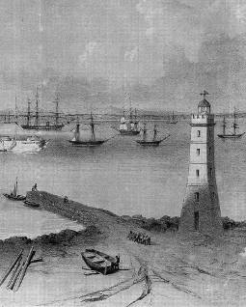
Convict labour was used to build much of the early infrastructure in Williamstown. Prisoners worked on several projects at Point Gellibrand, including the battery, the powder magazine, the Tide Gauge House (now relocated in Commonwealth Reserve) and a tidal wall at Gellibrand Point. In 1848, the Time Ball Tower was erected. It was initially used as a lighthouse (see photo) and then as a timing signal to passing vessels which enabled them to set their chronometers (clocks). ⁹
Photo source: www.lighthouse.net.au/lights/VIC/Williamstown/Williamstown%20Lighthouse.htm#History

After the 1850s prisoners worked on land reclamation and road building around the Alfred Graving Dock and between Osborne Street and the battery.

Other early industries to be established in Williamstown included woollen mills and
associated industries. One of these was the
Alfred Woollen Mill in Osborne St. The
mill began operating in 1878 and was still in use
in the 1930s, although its ownership had changed. ¹⁰
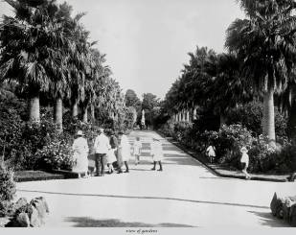
Williamstown’s Botanic Gardens were one of the earliest to be established in Victoria. The gardens were designed by Edward La Trobe and some elements of the original 1860 plan are still evident. Changes in the early part of the twentieth century saw the addition of an ornamental lake, palm avenue (see photo) and new gates at the north-east corner.

Towards the end of the nineteenth century, Williamstown was being promoted as a health resort and the beach area adjacent to the Botanic Gardens was particularly popular. The Williamstown Baths were built in 1888, at the current site of the kiosk, and hot sea baths were added in 1902 (later destroyed by a storm in 1934). In the early 1900s, the promenade and bluestone wall were built along the foreshore. The dressing pavilion (now a restaurant), and life saving clubrooms were added in the 1930s.

Shipbuilding was also at the forefront of activity in Williamstown.
In the early 1900s, activity around the port area continued with the Commonwealth Government commissioning a number of ships to replace those lost during WW I. Having sold the dockyards to the Melbourne Harbour Trust in the 1920s, the Commonwealth then bought them back in order to meet the shipbuilding requirements as a result of WW II. ¹¹

More recent developments
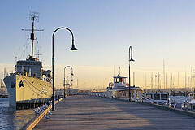
Williamstown’s maritime connections are still apparent today, including the naval dockyards which are located at the eastern tip of the neighbourhood. Until 1986, the dockyards were under the control of the Commonwealth government but have since had several owners and
are now owned by BAE. The dockyards play an important strategic role as a military shipbuilder and are one of the city’s largest employers. Apart from the dockyards, boating activity, particularly around Nelson Place, is oriented towards recreational boating and associated industries.

Williamstown’s history is evident in its heritage buildings and streetscapes although some of that history has been lost, as buildings were demolished to make way for new development. In the 1950s, the historic Langhorne bluestone wool store in Nelson Place was demolished by the former Housing Commission of Victoria. The Nelson Heights high rise flats were constructed on the site in the late 1960s to ease the chronic housing shortage in Melbourne. A second housing block (Floyd Lodge) was also developed in Hanmer Street.

Until the opening of the West Gate Bridge in 1978, Williamstown was relatively undiscovered except to local residents and those who lived in the west. The construction of the new bridge meant that Williamstown was much more accessible by road, providing a direct link to central Melbourne. In turn, Williamstown’s close proximity to the City, expanses of coastline and historical buildings made it attractive to new residents and visitors. ¹²

Today, the Williamstown neighbourhood is a popular destination for people visiting its beaches and cafes. Many houses and buildings have been restored and residents and visitors can take advantage of the broad range of cultural activities that are on offer.

C. The Current Environment

Land uses
The land use in the Williamstown neighbourhood is predominantly residential, with an extensive coastal strip of open space along the eastern and southern boundaries.

Williamstown has two main commercial areas (B1Z on the map below). The larger of the two is located close to the Ferguson Street and Douglas Parade junction and is the core retail centre of the Williamstown shopping centre. The second runs along Nelson Parade, opposite Commonwealth Reserve and is a major tourist precinct within the area.

Heading further south along Nelson Parade, there are several areas which are zoned for industrial uses, although much of this the land is currently unused.

Scattered throughout the neighbourhood are a number of public open space zones (PPRZ). Most of these are smaller spaces, although as mentioned earlier, there are large tracts of open space extending along much of the coastal boundary.

There are also a number of areas designated for public use (PUZ) and these are used for education purposes and the local hospital.

Other land uses are generally confined to port activity (SUZ5 on the map) or are controlled by the Port of Melbourne Planning Scheme (POMP). The Department of Sustainability and Environment (DSE) is the Responsible Authority in both instances. There is also a small parcel of Commonwealth owned land (CA). It falls under the jurisdiction of the Federal Government and therefore any development or use is outside the planning controls of the Hobsons Bay City Council.

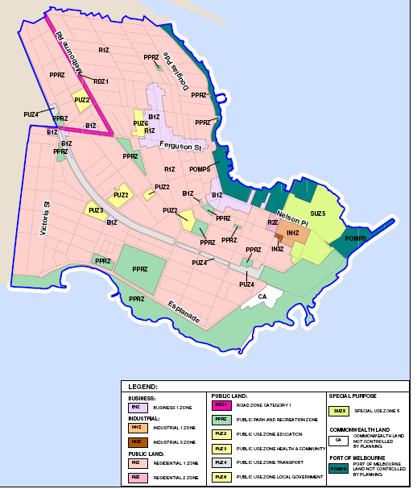
Land use zones
Public Land | Business
PPRZ Public Park Recreation Zone | B1Z Business 1 Zone
PUZ2 Public Use Zone Education | Industrial
PUZ3 Public Use Zone Health & Community | IN1Z Industrial 1 Zone
PUZ4 Public Use Zone Transport | IN3Z Industrial 3 Zone
PUZ6 Public Use Zone Local Government | Special Purpose
RDZ1 Road Zone Category | SUZ5 Special Use Zone 5
Residential | Commonwealth Land
R1Z Residential 1 Zone | CA Commonwealth land not controlled by the Hobsons Bay Planning Scheme.
R2Z Residential 2 Zone | Port of Melbourne
 | POMPS Port of Melbourne land not controlled by the Hobsons Bay Planning Scheme

Natural features and parks
Williamstown’s major natural feature is its coastline. Just offshore, at the north-east corner of the neighbourhood, are the lower end of the Spit and the mouth of Greenwich Bay.

Moving south, the coastline continues to the Point Gellibrand Coastal Heritage Park at the eastern tip. Parks Victoria and Hobsons Bay City Council are working together to develop this park, which forms part of the Altona Coastal Parklands. Revegetation has begun around Shelley Beach. The area was once covered by coastal saltbush but until recently was extremely degraded as a result of previous uses. Local community groups are working with Parks Victoria to re-establish indigenous plants and grasses.

Shelley Beach is also the location of a ‘lava bubble’ which resulted from volcanic activity in the area. As lava flowed to the shoreline, gases in the lava built up and created a large bubble three metres in diameter. ¹³

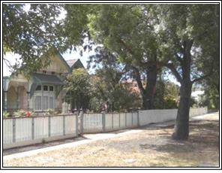
Residential development
Residential development in the Williamstown neighbourhood is an eclectic mix of housing types and streetscapes. In most streets, there are examples of heritage housing and in some cases, the heritage significance of the streetscape is predominantly intact. In other streets, heritage housing sits alongside more recent development. A blanket heritage overlay applies to the neighbourhood.

There is also a wide variation in the size of housing lots, ranging from expansive blocks with large houses and gardens to smaller lots just wide enough to accommodate a single fronted cottage. Similarly, the character of the streets is very diverse. In some parts, the streets are wide with bluestone kerbing and large street trees while in other areas the streets are much narrower and the housing is set close to the footpath.

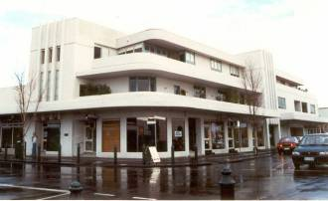
Along with increased housing densities in the residential areas, a number of commercial and industrial sites have been converted to apartment living. The former Nelson Bros. Funeral Parlour in Douglas Parade (see photo) is an example of this changed use, with retail on the street level and apartments above.

Community library, centres and halls
The new Williamstown library is located in Ferguson Street and provides a range of library services and meeting spaces for hire.

Williamstown has a range of halls and centres, some of which have function spaces available hire. The Williamstown Community and Education Centre is based in Joan Kirner House in Thompson Street. The building is owned by the State Government and is leased to the Hobsons Bay City Council. The centre is managed by a community board of management. The centre offers a diverse range of educational, cultural and recreational activities and has rooms for hire to the public. Classes on offer include: adult education and personal development courses; and art and craft classes for adults and children. A number of community groups are also based at the centre.

The former offices of the Hobsons Bay City Council in Ferguson Street, adjacent to the library, have been restored and renovated and include a range of spaces which can be hired by the public.
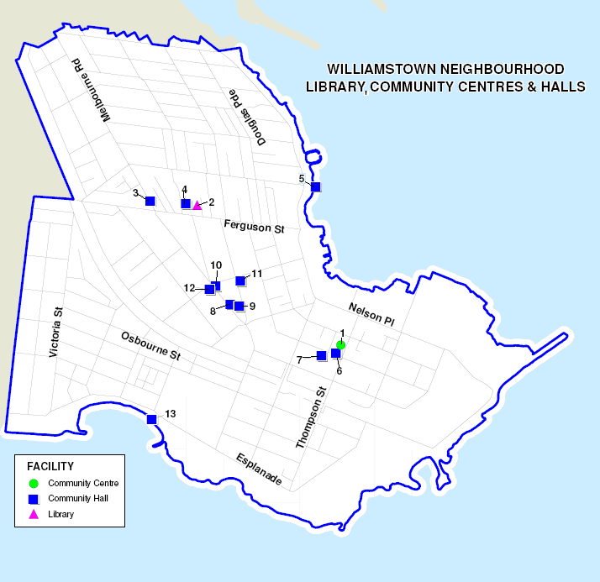

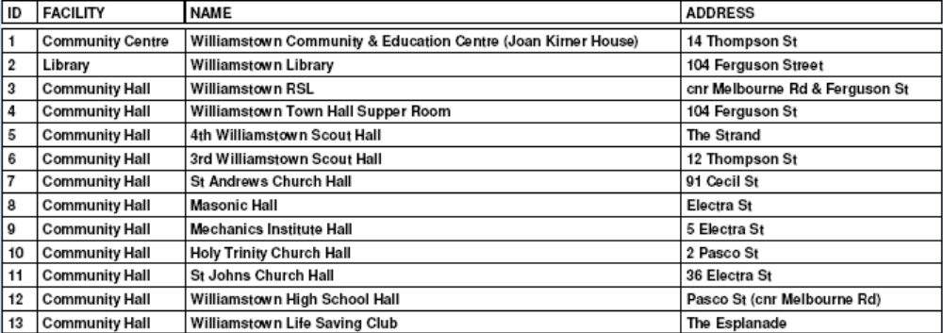

Children’s services
The information in this section on children’s services has been update. Please be aware that the map contains out-of-date information.

There is one maternal and child health centre operating from Monday to Friday in the Williamstown neighbourhood. The service is available to all families within the municipality with newborn babies through to young children. The service is co-located with the Robina Scott Kindergarten, opposite the Town Hall precinct in Ferguson Street.

There are three long day child care centres in the neighbourhood. Kids By the Bay is based in Cecil Street and Bright Steps is in Power Street.

The Robina Scott Kindergarten (for 4 year olds) is in Ferguson Street.
(As previously noted and for the purposes of this profile, Williamstown neighbourhood includes the area east of the Bayview Street. The Rifle Range Children’s Centre which includes child care and kindergarten is included in the the Williamstown North-Rifle Range neighbourhood profile.)

Schools
There are three primary schools in Williamstown: two are government schools and one is a Catholic school. Williamstown Primary School and Saint Mary’s Catholic school are on adjacent sites in Cecil Street. To the north, on Melbourne Road, is Williamstown North Primary School.

In addition, the area has one secondary college, Williamstown High School (Pascoe Campus), which is a senior campus for Years 10-12 students. Students in Years 7-9 attend the Bayview campus, located just outside the Williamstown neighbourhood, in the Williamstown North neighbourhood.

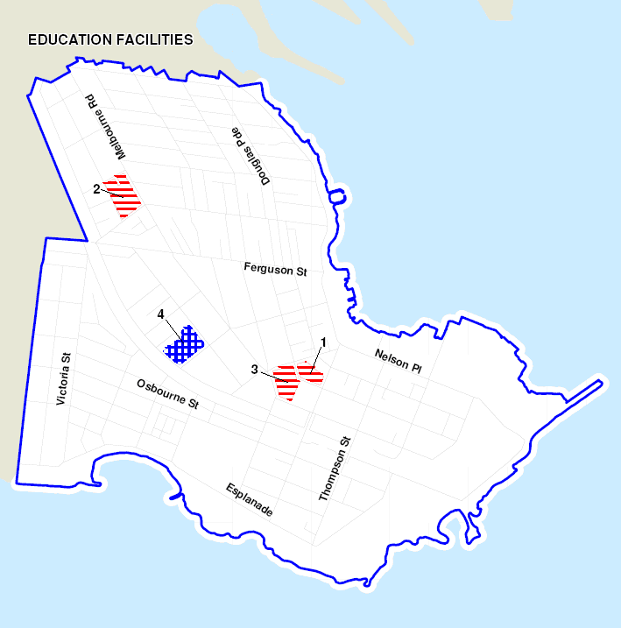

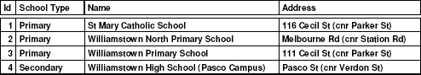

Recreational facilities and open space
The Williamstown neighbourhood has a range of open space, varying from a small number of local parks located throughout the neighbourhood to the ribbon of open space and parkland that wraps the coastline.

The junction of Yarra Street and The Strand, at the north east corner of the neighbourhood, marks the commencement of a series of linked reserves. These extend down to Ferguson Street, where in nearby Commonwealth Reserve there are a number of tennis courts. A shared trail passes along the coast and extends south, before reaching Point Gellibrand Heritage Park.

Point Gellibrand is the southern most point in Williamstown and is the location of the Williamstown Cricket Ground. The ground is used for both cricket and football. Tennis courts are also located nearby. (Details of the planned upgrade of facilities at the ground are outlined in ‘What’s Ahead’ at the end of this section of the profile.)

Past this point, adjacent to The Esplanade, is another band of open space which includes Williamstown Beach. Near The Esplanade are the Williamstown Botanic Gardens, mentioned earlier. Adjacent to the gardens is Fearon Reserve. The reserve has two ovals used for football and cricket, together with cricket nets and clubrooms. Also located here are a lacrosse field, clubrooms and a synthetic box lacrosse court.

At nearby Hatt Reserve and also at Robertson Reserve, there are junior cricket grounds with synthetic wickets.

Dennis Reserve, just off Ferguson Street in Melbourne Road, caters for tennis and bowling. The Reserve has two synthetic tennis courts and three bowling greens.

There are two croquet lawns and clubrooms in Victoria Street, adjacent to Gray Reserve.

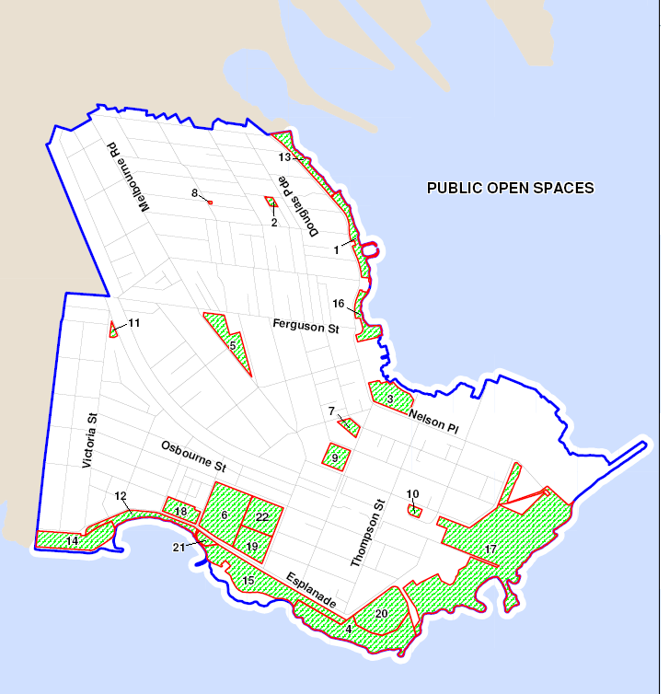

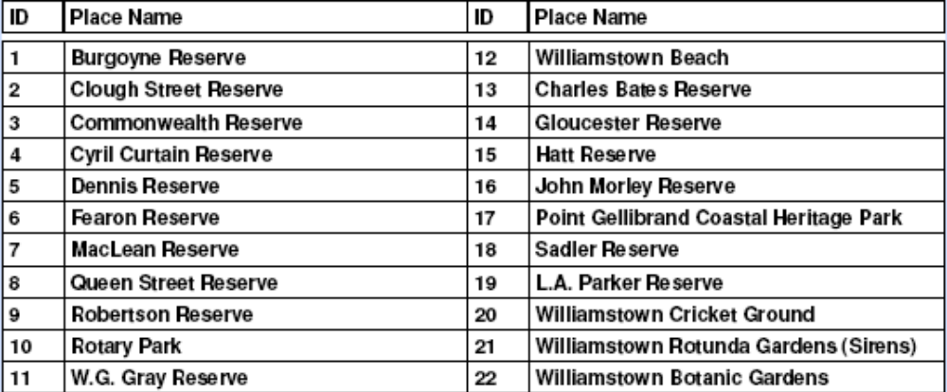

Cultural Activities
The Williamstown neighbourhood offers a diverse range of cultural activities and events throughout the year.
- The Williamstown Literary Festival is a writing event with a special focus on the west.
- The Sounds of Summer is held on a number of weekends and offers free music in Commonwealth Reserve.
- Shakespeare in the Williamstown Botanical Gardens is held across several weekends each November.
- Tall Ships celebrates Williamstown’s maritime heritage and activities are held around Australia Day. The Enterprize, a replica of the ship that brought the first settlers to Melbourne in 1835, is permanently based in Williamstown.

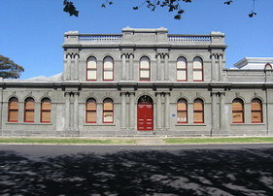
There are a number of venues available for arts activities in Williamstown including:
- Williamstown Town Hall in Ferguson Street
- Williamstown Mechanics Institute in Electra Street (see photo)
- Williamstown Little Theatre in Albert Street
- The Commonwealth Reserve Rotunda

Retail Centres
Williamstown is one of three major activity centres in Hobsons Bay. A large retail and commercial precinct extends along Douglas Parade and Ferguson Street. The centre offers an extensive mix of services including a major supermarket, five banks, together with a range of fresh food shops, cafes, home wares, clothing and speciality stores.

Nelson Place, opposite the Hobsons Bay waterfront, is a smaller precinct which caters for both locals and visitors to the area. It has a range of cafes, bars, bookstores and specialty shops.

Medical Centres
The Williamstown Hospital is located in Railway Crescent. The hospital provides emergency, acute medical and surgical, aged care and rehabilitation services.

There are three medical centres operating in the Williamstown neighbourhood.

The Clinic Williamstown  107 Ferguson Street | Williamstown Medical Centre  76 Stevedore Street
Williamstown General Practitioners Group
Suite 2/81 Ferguson Street

Dentists
There are five dental surgeries located in Williamstown.

Dr David Chua,  Dr Leslie Tu  87 Douglas Parade | Dr Shane Vereker  Dr Brendan Parker  Dr Vincent Tran,  35 Douglas Parade
Dr David W Bladen,  43 Douglas Parade | Dr Roland Goldberg,  72 Electra Street
Dr Kar Mun Chan,
Kiddies Dental Care
65 Electra Street
(Saturday only)

Pharmacies
There are three pharmacies in the neighbourhood. All are located in the main retail centre along Douglas Parade and Ferguson Street.

National Pharmacies  81 Ferguson St | Parade Pharmacy  44 Douglas Pde
Williamstown Village Pharmacy
35 Ferguson St

Public transport
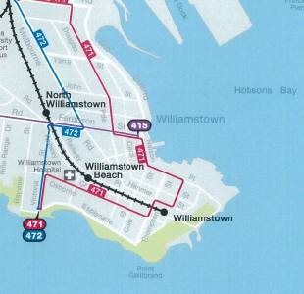
The Williamstown neighbourhood is serviced by both rail and bus services. The train line connects to central Melbourne, with stops at Williamstown North, Williamstown Beach and terminating at the Williamstown station. Rail passengers travelling to the City, or to Werribee and Geelong, change trains at Newport station.

Three bus routes pass through the neighbourhood. The 417 bus route to Laverton departs from the corner of Ferguson Street and The Strand, and then runs to Altona before arriving at Aircraft Station in Railway Avenue.

The 471 bus route links Williamstown and Sunshine. The route commences at the corner of Victoria Street and The Esplanade, runs via Newport and Altona North and terminates at the
Sunshine Railway Station.

The 472 bus service operates between Williamstown and Moonee Ponds. The route commences at the corner of Victoria Street and The Esplanade, passes through Footscray and Ascot Vale and ends at the Moonee Ponds Bus Terminal.

References

¹ Hobsons Bay City Council website, http://libraries.hobsonsbay.vic.gov.au/Page/page.asp?Page_Id=246&h=0#BM364

²Parks Victoria website, http://www.parkweb.vic.gov.au/resources05/05_1068.pdf

³ Hobsons Bay City Council website, http://www.hobsonsbay.vic.gov.au/libraries/Page/page.asp?Page_Id=246&h=0#BM371

⁴ Point Gellibrand Coastal Heritage Park Master Plan, revised 2003, Hobsons Bay City Council & Parks Victoria.

⁵ Hobsons Bay Planning Scheme 21.07-1 http://www.psdocs.dpcd.vic.gov.au/public/Hobsons%20Bay/21_mss07_hbay.doc

⁶ Meredith Gould Architects P/L, 1998, Williamstown Workshop and Slipways: Former Port of Melbourne Authority Site, heritage review, Parks Victoria.

⁷ http://www.hobsonsbay.vic.gov.au/page/page.asp?page_id=197#BM348

⁸ Vines G, 1993, Work in the West, No 1, Melbourne’s Living Museum of the West Incorporated, Maribyrnong Vic

⁹ Hobsons Bay Planning Scheme, op. cit.

¹⁰ Vines G, op. cit

¹¹ Meredith Gould Architects P/L, op. cit.

¹² Hobsons Bay Heritage Study: Thematic Environmental History (2003) www.hobsons.vic.gov.au/Files/Volume_1b_Thematic_Environmental_History.pdf

¹³ Parks Victoria http://www.parkweb.vic.gov.au/resources05/05_1068.pdf
Williamstown Neighbourhood
Data Profile

- Population Characteristics

Population: number and age structure
At the 2011 Census, Williamstown had a population of almost 10,600 people (12% of the municipality’s residents). Based on population estimates for 2015, the neighbourhood’s current population is approximately 11,380.

Looking at the change in Williamstown’s population size between the 2006 and 2011 Censuses, as shown in table and graph 1 below there was a four per cent increase resulting in 420 new residents. Within the neighbourhood’s age structure, the number of young and school aged children increased, as did the number of 18-24 year olds. Alongside this trend was a decrease in younger adults aged 25-34.

Among the older age groups, the main change was an increase in adults in the 50-69 age bracket, and particularly those aged in their sixties.

Table 1: Population and age structure Graph 1: Population change between 2016-11
 | 2011 | 2006 | 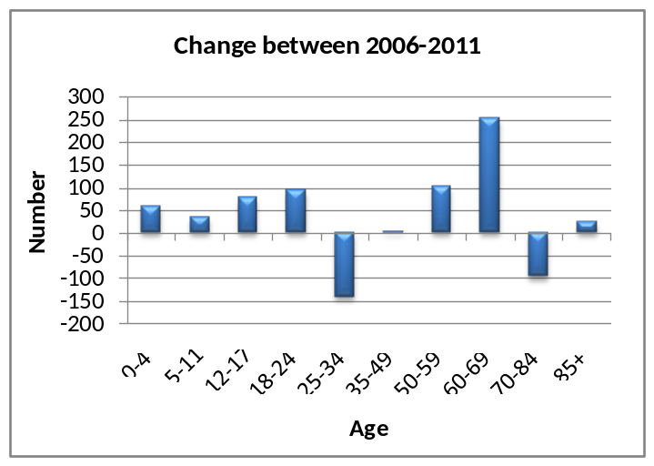Change  2006-2011
0-4 years | 737 | 676 | +61
5-11 years | 959 | 922 | +37
12-17 years | 826 | 748 | +78
18-24 years | 736 | 640 | +96
25-34 years | 1,011 | 1,152 | -141
35-49 years | 2,737 | 2,733 | +5
50-59 years | 1,566 | 1,463 | +103
60-69 years | 1,057 | 804 | +253
70-84 years | 718 | 813 | -95
85+ years | 242 | 218 | +25
Total population | 10,590 | 10,169 | +420

Source: ABS 2011 Census (Usual residence data) http://profile.id.com.au/hobsons-bay/home
When comparing the age structure of Williamstown residents against Hobsons Bay as a whole, as shown in graph 2, Williamstown has a slightly higher proportion of school aged children and adults aged between 35-69 years. On the other hand, it has a lower proportion of young adults (18-24 years) and those in what is described as the family forming age group (25-34 years).

Graph 2: Age structure of Williamstown and Hobsons Bay
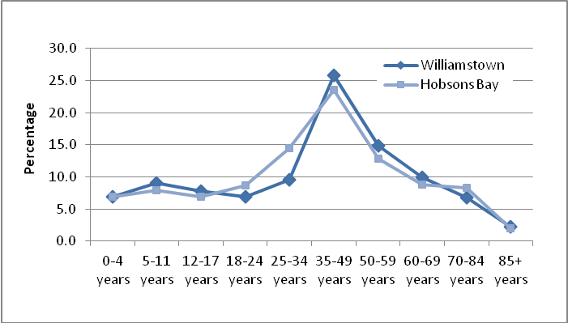
Source: ABS 2011 Census (Usual residence data) http://profile.id.com.au/hobsons-bay/home

Family and household types
There are a total of 4,193 households in Williamstown. Of these, 44 per cent are made up of families with children.

Among the 1,884 families who have children, the largest group is those with young children (19.8% are couple families; 3.2% are single parent families). Table 2 highlights that the main changes since the 2006 Census were an increase in families with young children (among couple families) and those with older children (across both couple and single parent families).

When compared to Hobsons Bay, Williamstown has a slightly higher proportion of families with children, most noticeably, couples with young children.

Table 2: Families with children
 | 2011 |  |  | 2006 |  |  | Williamstown  Change  2006-2011
Households with children | Number | % | Hobsons Bay % | Number | % | Hobsons Bay % | Williamstown  Change  2006-2011
Couples with children | 1,436 | 34.2 | 31.7 | 1,292 | 31.1 | 32.2 | +144
Couples with young children* | 830 | 19.8 | 17.4 | 756 | 18.2 | 17.1 | +75
Couples with mixed-age children | 185 | 4.4 | 3.9 | 170 | 4.1 | 4.6 | +15
Couples with older children** | 421 | 10.0 | 10.4 | 367 | 8.8 | 10.5 | +54
Single parents with children | 408 | 9.7 | 11.1 | 418 | 10.1 | 11.7 | -10
Single parents with young children | 133 | 3.2 | 3.5 | 162 | 3.9 | 4.5 | -29
Single parents with mixed-age children | 33 | 0.8 | 1.2 | 52 | 1.3 | 1.2 | -19
Single parents with older children | 241 | 5.8 | 6.4 | 204 | 4.9 | 6.0 | +38
Total households with children | 1,844 | 44.0 | 42.7 | 1,710 | 41.2 | 43.9 | +134
Total households | 4,193 | 100.0 | 100.0 | 4,150 | 100.0 | 100.0 | +44
* children aged under 15
** children aged 15 and over
Source: ABS 2011 Census (Enumerated data) http://profile.id.com.au/hobsons-bay/home

There are 2,149 households without children in Williamstown and they make up just over half of all households in the neighbourhood. The largest childless groups consist of couple and lone person households. Since the 2006 Census, the number of households without children has decreased slightly; this decrease has mainly been young couple and young lone person households.

There are only minor differences when comparing Williamstown with Hobsons Bay as a whole. Generally, Williamstown has a lower proportion of younger couple and lone person households and a slightly higher proportion of middle aged and older couples and lone person households.

Table 3: Households without children
 | 2011 |  |  | 2006 |  |  | Williamstown  Change  2006-2011
Households without children | Number | % | Hobsons Bay % | Number | % | Hobsons Bay % | Williamstown  Change  2006-2011
Couples without children | 947 | 22.6 | 23.5 | 940 | 22.6 | 22.8 | +7
Young couples without children | 290 | 6.9 | 8.6 | 342 | 8.2 | 7.9 | -52
Middle-aged couples without children | 368 | 8.8 | 7.1 | 343 | 8.3 | 7.1 | +25
Older couples without children | 289 | 6.9 | 7.8 | 256 | 6.2 | 7.7 | +34
Lone person households | 1,090 | 26.0 | 24.3 | 1,161 | 28.0 | 24.4 | -71
Young lone persons | 249 | 5.9 | 7.1 | 330 | 7.9 | 8.0 | -80
Middle-aged lone persons | 399 | 9.5 | 8.3 | 407 | 9.8 | 7.6 | -8
Older lone persons | 441 | 10.5 | 8.9 | 423 | 10.2 | 8.8 | +18
Group households | 112 | 2.7 | 3.8 | 119 | 2.9 | 3.2 | -7
Total households without children | 2,149 | 51.2 | 51.6 | 2,220 | 53.5 | 50.4 | -71
Total households | 4,193 | 100.0 | 100.0 | 4,149 | 100.0 | 100.0 | +44
- young: 15-44 years; middle aged: 45-64 years; older: 65+ years
Source: ABS 2011 Census (Enumerated data) http://profile.id.com.au/hobsons-bay/home

Cultural diversity of residents
Approximately 21 per cent (2,190) of Williamstown residents were born overseas, well below the municipal rate of 31 per cent. The number of overseas born increased by just over 400 between 2006 and 2011 and by far the largest share of that increase was among residents from English speaking countries.

Overall, the neighbourhood has a significantly lower proportion of residents from non-English speaking countries than does Hobsons Bay (Williamstown 10.6%; Hobsons Bay 23.1%).

Table 4: Overseas born residents
 | 2011 |  |  | 2006 |  |  | Change  2006- 2011
Birthplace | Number | % | Hobsons Bay % | Number | % | Hobsons Bay % | Change  2006- 2011
Total Overseas born | 2,190 | 20.7 | 30.8 | 2,006 | 19.7 | 29.0 | +184
Non-English speaking backgrounds | 1,125 | 10.6 | 23.1 | 1,082 | 10.6 | 21.4 | +42
Main English speaking countries | 1,065 | 10.1 | 7.7 | 924 | 9.1 | 7.6 | +141
Australia | 7,883 | 74.5 | 63.5 | 7,551 | 74.3 | 63.7 | +332
Not Stated | 515 | 4.9 | 5.6 | 612 | 6.0 | 7.2 | -97
Total Population | 10,587 | 100.0 | 100.0 | 10,168 | 100.0 | 100.0 | +419
Source: ABS 2011 Census (Usual residence data) http://profile.id.com.au/hobsons-bay/home
Looking at the 10 main countries of birth, residents born in the United Kingdom (UK) are clearly the largest group of Williamstown’s overseas born residents, and their numbers have increased slightly since the 2006 Census. New Zealand is the next main birthplace and thereafter, the numbers from other countries are relatively small.
After the UK, the largest increase since 2006 was among residents from India.

Table 5: Country of birth for residents born overseas
 | 2011 |  |  | 2006 |  |  | Change  2006- 2011
Birthplace | Number | % | Hobsons Bay % | Number | % | Hobsons Bay % | Change  2006- 2011
United Kingdom | 725 | 6.8 | 4.5 | 629 | 6.2 | 4.8 | +96
New Zealand | 160 | 1.5 | 1.9 | 165 | 1.6 | 2.0 | -5
Italy | 85 | 0.8 | 2.0 | 113 | 1.1 | 2.3 | -28
India | 78 | 0.7 | 2.8 | 23 | 0.2 | 0.9 | +55
Greece | 74 | 0.7 | 1.4 | 88 | 0.9 | 1.6 | -14
Germany | 62 | 0.6 | 0.6 | 61 | 0.6 | 0.6 | +0
Croatia | 62 | 0.6 | 0.7 | 70 | 0.7 | 0.8 | -9
South Africa | 62 | 0.6 | 0.3 | 40 | 0.4 | 0.2 | +22
Serbia / Montenegro  (fmr Yugoslavia) | 55 | 0.5 | 0.9 | 41 | 0.4 | 1.1 | +14
United States of America | 52 | 0.5 | 0.3 | 37 | 0.4 | 0.2 | +16
Source: ABS 2011 Census (Usual residence data) http://profile.id.com.au/hobsons-bay/home
Table 6 shows when overseas born residents of Williamstown arrived in Australia.
Since the early 2000s, there has been a noticeable lift in the number of residents of Williamstown who were born overseas (640 new residents since 2011) and this trend is evident across the municipality.

Table 6: Year of arrival in Australia of overseas born residents
 | 2011
Year of arrival in Australia | Number | % | Hobsons Bay %
2006 to 9 Aug 2011 | 391 | 17.7 | 20.8
2001 to 2005 | 249 | 11.3 | 9.1
1991 to 2000 (10 year period) | 247 | 11.2 | 10.9
1981 to 1990 (10 year period) | 260 | 11.8 | 13.2
1971 to 1980 (10 year period) | 240 | 10.9 | 10.6
1961 to 1970 (10 year period) | 355 | 16.1 | 17.0
Arrived in 1960 or earlier | 383 | 17.4 | 13.9
Not stated | 81 | 3.7 | 4.4
Total | 2,207 | 100.0 | 100.0
Source: ABS 2011 Census (Usual residence data) http://profile.id.com.au/hobsons-bay/home

People with a disability
The number of people who have a disability is drawn from the findings of the national Survey of Disability, Ageing and Carers (2009), conducted by the Australian Bureau of Statistics (ABS) in partnership with the Disability Policy and Research working group. Based on the survey findings, disability estimates are produced for each local government area (LGA).

It is estimated that 17.1 per cent of the Hobsons Bay population (who live in a private dwelling) has a disability. Applying this figure to Williamstown suggests approximately 1,800 residents may have a disability.

In addition to the 2009 survey, the past two Censuses have included a question on whether help or supervision is required with one or more of the core activities involving self-care, communication and mobility. It is important to note that these results do not reflect the true extent of disability in the community, as people with a disability do not always require assistance.

The findings of the 2011 Census show that 428 Williamstown residents (4%) said they need help with a core activity, slightly below the rate for Hobsons Bay (5.2%). Since the 2006 Census, the neighbourhood figure has remained relatively stable, with a marginal increase of 0.1 per cent (36 people), slightly less than the 0.8 per cent increase for Hobsons Bay.

Not surprisingly, the table below shows those aged 85 years and over have the highest need for assistance, although compared to the municipality their need for assistance is much lower (Williamstown 44.3%; Hobsons Bay 51.7%).

Apart from children under 12, where the figure is slightly above the municipal rate, Williamstown has a comparatively low level of residents needing assistance.

Table 7: Residents who need assistance with a core activity
 | 2011
 | Number | % of total age group | Hobsons Bay %
0-4 | 9 | 1.3 | 1.0
5-11 | 20 | 3.0 | 2.6
12-17 | 14 | 1.0 | 1.9
18-24 | 103 | 1.8 | 2.2
25-34 | 29 | 4.6 | 7.6
35-49 | 17 | 4.0 | 10.0
50-59 | 30 | 10.6 | 14.4
60-69 | 27 | 12.8 | 22.1
70-84 | 71 | 27.0 | 30.6
85+ | 107 | 44.3 | 51.7
Total persons needing assistance | 428 | 4.0 | 5.2
Source: ABS 2011 Census (Usual residence data) http://profile.id.com.au/hobsons-bay/home

Looking at the changes that have occurred over the five years to 2011, graph 3 highlights the marked increase in the proportion of older residents (85 years and over) requiring support, together with a slight increase among 5-11 year olds. In contrast, the proportion of residents aged between 50-69 years who need assistance decreased, compared to Hobsons Bay.

Graph 3: Changing in need for assistance for Williamstown residents
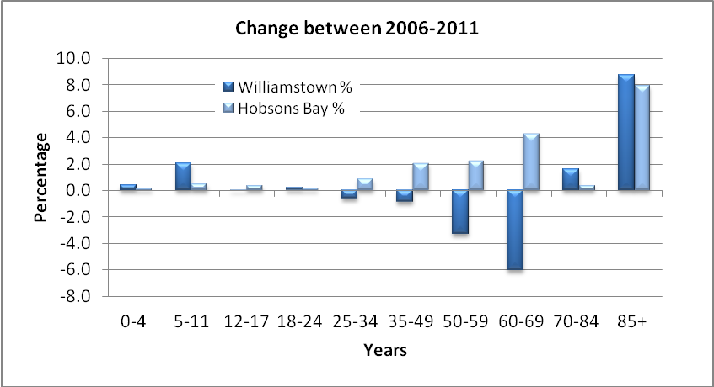
Source: ABS 2011 Census (Usual residence data) http://profile.id.com.au/hobsons-bay/home

Participation in education
Approximately 25 per cent of Williamstown’s residents are enrolled in education which is three per cent above the participation rate for Hobsons Bay (22%).

Just over than 15 per cent of the neighbourhood’s population attends either primary or secondary school and again this is slightly above the enrolment rate for the municipality, reflecting a slightly higher proportion of school aged children living in Williamstown.

Since the 2006 Census, participation in post-secondary education (TAFE, university and other educational institutions) has remained relatively stable, as have enrolment rates across the municipality.

Approximately 70 per cent of residents are not enrolled in any form of education which is on a par with the municipal rate.

Table 8: Participation in education (persons aged 15 years and over)
 | 2011 |  |  | 2006 |  |  | Change  2006- 2011
 | Number | % | Hobsons Bay % | Number | % | Hobsons Bay % | Change  2006- 2011
Pre-school | 210 | 2.0 | 1.6 | 218 | 2.1 | 1.6 | -7
Primary school | 882 | 8.3 | 7.0 | 821 | 8.1 | 7.8 | +60
Secondary school | 756 | 7.1 | 5.9 | 664 | 6.5 | 6.2 | +91
TAFE | 168 | 1.6 | 1.9 | 155 | 1.5 | 1.7 | +14
University | 520 | 4.9 | 4.2 | 420 | 4.1 | 3.2 | +100
Other | 91 | 0.9 | 1.1 | 98 | 1.0 | 0.9 | -7
Not attending | 7,362 | 69.5 | 71.1 | 7,055 | 69.4 | 70.2 | +306
Not stated | 607 | 5.7 | 7.1 | 738 | 7.3 | 8.3 | -130
Total | 10,597 | 100.0 | 100.0 | 10,169 | 100.0 | 100.0 | +427
Source: ABS 2011 Census (Usual residence data) http://profile.id.com.au/hobsons-bay/home

Williamstown residents have a far higher rate of year 12 completion, compared to residents of the municipality (10% higher).

Since 2006, the completion rate has increased substantially across the municipality, with the rate of change slightly lower in Williamstown (5.4% increase: Hobsons Bay 7.5% increase). As a result, there has been a corresponding decrease in the proportion of residents in the neighbourhood and the municipality who left school early.

Table 9: Highest level of schooling completed (persons aged 15 years and over)
 | 2011 |  |  | 2006 |  |  | Change  2006- 2011
Level of schooling | Number | % | Hobsons Bay % | Number | % | Hobsons Bay % | Change  2006- 2011
Year 8 or below | 447 | 5.3 | 8.3 | 547 | 6.7 | 10.2 | -100
Year 9 or equivalent | 400 | 4.7 | 6.2 | 428 | 5.3 | 7.1 | -28
Year 10 or equivalent | 973 | 11.5 | 13.5 | 972 | 12.0 | 15.1 | +1
Year 11 or equivalent | 940 | 11.1 | 11.7 | 946 | 11.6 | 13.1 | -7
Year 12 or equivalent | 5,100 | 60.3 | 50.1 | 4,460 | 54.9 | 42.6 | +640
Did not go to school | 46 | 0.5 | 1.5 | 58 | 0.7 | 1.8 | -12
Not stated | 546 | 6.5 | 8.6 | 718 | 8.8 | 10.2 | -172
Total persons aged 15+ | 8,452 | 100.0 | 100.0 | 8,129 | 100.0 | 100.0 | +322
Source: ABS 2011 Census (Usual residence data) http://profile.id.com.au/hobsons-bay/home

Along with rising school completion rates, the percentage of residents with a qualification has also risen. Since 2006, there has been a 5.2 per cent increase in residents with a bachelor or higher degree and while the municipal rate of increase was similar, a much higher proportion of Williamstown residents have these qualifications (14% more).

The proportion of neighbourhood residents with diploma or vocational qualifications has increased only marginally, and compared with Hobsons Bay, Williamstown residents are less likely to have vocational qualifications.

NB: The decrease in a ‘not stated’ response between 2006 and 2011 may have impacted on the extent of these changes.

Table 10: Highest qualification
 | 2011 |  |  | 2006 |  |  | Change  2006 to 2011
 | Number | % | Hobsons Bay % | Number | % | Hobsons Bay % | Change  2006 to 2011
Bachelor or Higher degree | 3,011 | 35.5 | 21.1 | 2,468 | 30.3 | 16.1 | +542
Advanced Diploma or Diploma | 817 | 9.6 | 8.1 | 732 | 9.0 | 6.6 | +84
Vocational | 1,022 | 12.0 | 15.2 | 1,040 | 12.8 | 15.0 | -18
No qualification | 2,974 | 35.0 | 44.8 | 2,961 | 36.4 | 49.3 | +13
Not stated | 665 | 7.8 | 10.8 | 942 | 11.6 | 13.0 | -277
Total persons aged 15+ | 8,488 | 100.0 | 100.0 | 8,143 | 100.0 | 100.0 | +345
Source: ABS 2011 Census (Usual residence data) http://profile.id.com.au/hobsons-bay/home

Internet access
Access to the internet, particularly broadband, is an important tool that is now used in all aspects of life and that importance will only increase over time. Lack of access to the internet is considered to be a factor in compounding disadvantage, particularly in relation to education, employment, and social connections.

Just over three quarters of Williamstown residents have an internet connection and that figure increased by 14 per cent between 2006 and 2011. Over that period, connection to broadband has grown substantially across the whole of the municipality and while Williamstown still has a higher level of connection compared Hobsons Bay, the gap has closed a little since 2006.

Table 11: Households with internet connection
 | 2011 |  |  | 2006 |  |  | Change  2006-2011
Connection type | Number | % | Hobsons Bay % | Number | % | Hobsons Bay % | Change  2006-2011
Total internet connection | 3,250 | 77.5 | 71.8 | 2,643 | 63.6 | 55.7 | +607
Broadband connection | 2,926 | 69.8 | 65.0 | 1,863 | 44.9 | 37.9 | +1,064
Dial-up connection | 141 | 3.4 | 2.8 | 762 | 18.4 | 17.2 | -621
Other connection* | 183 | 4.4 | 3.9 | 18 | 0.4 | 0.6 | +165
No internet connection | 721 | 17.2 | 21.3 | 1,268 | 30.5 | 36.9 | -547
Not stated | 221 | 5.3 | 6.9 | 242 | 5.8 | 7.3 | -21
Total households | 4,192 | 100.0 | 100.0 | 4,153 | 100.0 | 100.0 | +39
* includes internet access through mobile phones, set-top boxes, games machines or connections other than dial-up or broadband.
Source: ABS 2011 Census (Usual residence data) http://profile.id.com.au/hobsons-bay/home

- Labour Force Characteristics

Labour force participation
Labour force participation refers to the population aged 15 years and over who are either employed or unemployed and actively looking for work. Not in the labour force refers to those who are not looking for work such as retirees, carers, non-working parents and those with a disability who are unable to work.

Approximately two thirds of the Williamstown population, aged 15 years and over, are in the labour force. Participation in the labour force rose slightly over the five years to 2011 and is just over four per cent above the municipal rate.

The percentage of those not in the labour force remained relatively stable, while the Hobsons Bay figure fell by 1.5 per cent.

Table 12: Labour force participation
 | 2011 |  |  | 2006 |  |  | Change  2006-2011
 | Number | % | Hobsons Bay % | Number | % | Hobsons Bay % | Change  2006-2011
Total labour force | 5,511 | 65.3 | 60.9 | 5,223 | 64.2 | 59.1 | +288
Not in the labour force | 2,576 | 30.5 | 33.2 | 2,456 | 30.2 | 34.7 | +120
Labour force status not stated | 357 | 4.2 | 5.9 | 451 | 5.5 | 6.2 | -94
Total persons aged 15+ | 8,444 | 100.0 | 100.0 | 8,130 | 100.0 | 100.0 | +314
Source: ABS 2011 Census (Usual residence data) http://profile.id.com.au/hobsons-bay/home

Just over 96 per cent of the Williamstown population are employed, the majority (60.4 per cent) work full-time. The employment rate is around two per cent above the municipal figure, although Williamstown has a slightly higher proportion of residents in part-time work. Since 2006, part-time employment rates grew in the neighbourhood and across the municipality.

The Williamstown unemployment rate in 2011 was 3.7 per cent, close to two per cent lower than the Hobsons Bay rate. Both locally and across the municipality, a higher proportion of those who are unemployed were looking for a full-time job, consistent with the 2006 Census findings.

Table 13: Employment status
 | 2011 |  |  | 2006 |  |  | Change  2006-2011
 | Number | % | Hobsons Bay % | Number | % | Hobsons Bay % | Change  2006-2011
Employed | 5,305 | 96.3 | 94.4 | 5,033 | 96.4 | 94.1 | +272
Employed full-time | 3,331 | 60.4 | 61.3 | 3,240 | 62.0 | 62.8 | +91
Employed part-time | 1,916 | 34.8 | 31.0 | 1,693 | 32.4 | 28.6 | +223
Hours worked not stated | 59 | 1.1 | 2.1 | 100 | 1.9 | 2.8 | -41
Unemployed (Unemployment rate) | 206 | 3.7 | 5.6 | 190 | 3.6 | 5.9 | +16
Looking for full-time work | 129 | 2.3 | 3.6 | 132 | 2.5 | 3.9 | -3
Looking for part-time work | 77 | 1.4 | 2.0 | 58 | 1.1 | 1.9 | +19
Total Labour Force | 5,511 | 100.0 | 100.0 | 5,223 | 100.0 | 100.0 | +288
Source: ABS 2011 Census (Usual residence data) http://profile.id.com.au/hobsons-bay/home
Employment by industry
The key industries that employ Williamstown residents* are:
- professional, scientific and technical services (12.3%)
- education and training (11.6%)
- health care and social assistance (10.7%)

* within Hobsons Bay and outside the municipality

Between 2006 and 2011, an additional 284 residents found employment although the key areas of employment remained unchanged. The largest group of Williamstown workers are employed in professional, scientific and technical services (12.3%). This figure is four per cent higher than for the municipality and has increased a little since the 2006 Census.

Education and training, together with health care and social assistance, employ 22 per cent of residents, around four per cent above the Hobsons Bay figure.

While it is a mid-range industry in terms of employment of Williamstown residents, largest growth between 2006 and 2011 was in financial and insurance services, marginally above professional and scientific services.

Manufacturing, which is the largest employer of Hobsons Bay workers, is the fifth largest of Williamstown workers, and job numbers dropped locally and across the municipality in the five years to 2011.

Table 14: Industry sector of employment
 | 2011 |  |  |  | 2006 |  |  | Change  2006-2011
 | Number | % |  | Hobsons Bay % | Number | % | Hobsons Bay % | Change  2006-2011
Professional, Scientific and Technical Services | 650 | 12.3 |  | 8.2 | 584 | 11.6 | 7.4 | 66
Education and Training | 617 | 11.6 |  | 7.8 | 566 | 11.3 | 7.0 | 50
Health Care and Social Assistance | 543 | 10.2 |  | 9.4 | 530 | 10.6 | 8.7 | 13
Retail Trade | 427 | 8.1 |  | 9.1 | 415 | 8.3 | 9.9 | 12
Manufacturing | 389 | 7.3 |  | 11.3 | 457 | 9.1 | 14 | -68
Construction | 381 | 7.2 |  | 7.7 | 330 | 6.6 | 6.7 | 51
Public Administration and Safety | 362 | 6.8 |  | 6.4 | 338 | 6.7 | 6.4 | 25
Financial and Insurance Services | 294 | 5.5 |  | 4.9 | 227 | 4.5 | 4.6 | 67
Transport, Postal and Warehousing | 271 | 5.1 |  | 7.5 | 237 | 4.7 | 7.8 | 34
Accommodation and Food Services | 262 | 4.9 |  | 5.8 | 266 | 5.3 | 5.4 | -4
Wholesale trade | 200 | 3.8 |  | 4.6 | 233 | 4.6 | 5.1 | -33
Information Media and Telecommunications | 187 | 3.5 |  | 2.4 | 161 | 3.2 | 2.6 | 26
Other Services | 159 | 3 |  | 3.4 | 150 | 3 | 3.3 | 9
Administrative and Support Services | 151 | 2.8 |  | 3.6 | 156 | 3.1 | 3.9 | -5
Arts and Recreation Services | 138 | 2.6 |  | 2.1 | 119 | 2.4 | 1.9 | 19
Rental, Hiring and Real Estate Services | 117 | 2.2 |  | 1.5 | 99 | 2 | 1.5 | 18
Inadequately described or not stated | 102 | 1.9 |  | 2.7 | 103 | 2 | 2.9 | -1
Electricity, Gas, Water and Waste Services | 44 | 0.8 |  | 0.9 | 28 | 0.5 | 0.7 | 16
Agriculture, Forestry and Fishing | 6 | 0.1 |  | 0.2 | 13 | 0.3 | 0.2 | -7
Mining | 4 | 0.1 |  | 0.2 | 9 | 0.2 | 0.2 | -5
Inadequately described or not stated | 102 | 1.9 | 2.7 |  | 103 | 2.0 | 2.9 | -1
Total employed persons aged 15+ | 5,304 | 100.0 | 100.0 |  | 5,020 | 100.0 | 100.0 | +284
Source: ABS 2011 Census (Usual residence data) http://profile.id.com.au/hobsons-bay/home

The main occupations of Williamstown residents are as
- professionals (22.7%)
- managers (18.5%)
- clerical and administrative workers (17.4%)
- technicians and trades workers (14.7%).

There has been virtually no change to these percentages since 2006, although numerically the largest increase was for those employed as professionals (+94).

Relative to Hobsons Bay, Williamstown has a much higher proportion of professionals and managers and a lower proportion of machinery operators and labourers.

Table 15: Occupation
 | 2011 |  |  | 2006 |  |  | Change  2006-2011
 | Number | % | Hobsons Bay % | Number | % | Hobsons Bay % | Change  2006-2011
Managers | 983 | 18.5 | 12.4 | 935 | 18.6 | 11.8 | +48
Professionals | 1,793 | 33.8 | 22.8 | 1,699 | 33.8 | 20.2 | +94
Technicians and Trades Workers | 504 | 9.5 | 13.5 | 472 | 9.4 | 14.1 | +33
Community and Personal Service Workers | 377 | 7.1 | 8.5 | 353 | 7.0 | 7.9 | +24
Clerical and Administrative Workers | 788 | 14.9 | 15.8 | 747 | 14.9 | 16.8 | +41
Sales Workers | 410 | 7.7 | 8.4 | 410 | 8.2 | 9.1 | +0
Machinery Operators And Drivers | 112 | 2.1 | 7.4 | 137 | 2.7 | 8.4 | -25
Labourers | 227 | 4.3 | 8.8 | 178 | 3.5 | 9.5 | +49
Inadequately described | 104 | 2.0 | 2.4 | 89 | 1.8 | 2.1 | +15
Total employed persons aged 15+ | 5,298 | 100.0 | 100.0 | 5,019 | 100.0 | 100.0 | +279
Source: ABS 2011 Census (Usual residence data) http://profile.id.com.au/hobsons-bay/home

Unpaid work and volunteering
Twenty one per cent of the Williamstown residents (1,773) are volunteers and this is consistent with the 2006 Census figure. The rate of volunteering in Williamstown is well above the Hobsons Bay figure of 14.4 per cent.

Table 16: Volunteer status (aged 15 years and over)
 | 2011 |  |  | 2006 |  |  | Change  2006- 2011
 | Number | % | Hobsons Bay % | Number | % | Hobsons Bay % | Change  2006- 2011
Volunteer | 1,773 | 21.0 | 14.3 | 1,742 | 21.4 | 14.1 | +31
Not a volunteer | 6,189 | 73.2 | 77.2 | 5,714 | 70.3 | 76.4 | +476
Volunteer work not stated | 489 | 5.8 | 8.5 | 675 | 8.3 | 9.5 | -186
Total persons aged 15+ | 8,451 | 100.0 | 100.0 | 8,131 | 100.0 | 100.0 | +321
Source: ABS 2011 Census (Usual residence data) http://profile.id.com.au/hobsons-bay/home

Almost one third of residents aged 15 years and over provide unpaid childcare which is around five per cent above the municipal figure. Three quarters of those providing care look after their own children.

By gender, 34.9 per cent of unpaid childcare is provided by women compared to 27.7 per cent by men in Williamstown. Compared to Hobsons Bay data, a higher proportion of Williamstown residents, both male and female, provide care.

Table 17: Unpaid child care (aged 15 years and over)
 | 2011 |  |  | 2006 |  |  | Change  2006-2011
Unpaid child care | Number | % | Hobsons Bay % | Number | % | Hobsons Bay % | Change  2006-2011
Provided unpaid child care (all) | 2,661 | 31.5 | 26.7 | 2,430 | 29.9 | 27.1 | +231
Cared for own child/ren | 1,944 | 23.0 | 19.7 | 1,782 | 21.9 | 19.5 | +162
Cared for other child/ren | 595 | 7.0 | 6.2 | 545 | 6.7 | 6.6 | +50
Cared for own child/ren and other child/ren | 122 | 1.4 | 0.8 | 103 | 1.3 | 0.9 | +19
No unpaid child care provided | 5,318 | 62.9 | 65.4 | 5,044 | 62.0 | 64.2 | +274
Not stated | 479 | 5.7 | 7.9 | 656 | 8.1 | 8.7 | -178
Total persons aged 15+ | 8,457 | 100.0 | 100.0 | 8,130 | 100.0 | 100.0 | +327
Source: ABS 2011 Census (Usual residence data) http://profile.id.com.au/hobsons-bay/home

Almost 1,100 residents (12.8%) of the neighbourhood, aged 15 years and over provide unpaid assistance to those with a disability, illness or who are elderly. A slightly higher proportion of people in Williamstown provide assistance when compared to Hobsons Bay as a whole and the proportion increased a little since 2006, both locally and across the municipality.

At the same time the number and proportion of Williamstown residents who do not provide assistance also rose.

Table 18: Unpaid assistance to a person with a disability, long term illness or old age
 | 2011 |  |  | 2006 |  |  | Change  2006- 2011
 | Number | % | Hobsons Bay % | Number | % | Hobsons Bay % | Change  2006- 2011
Provided unpaid assistance | 1,084 | 12.8 | 11.5 | 942 | 11.6 | 10.2 | +142
No unpaid assistance provided | 6,839 | 80.9 | 79.7 | 6,492 | 79.9 | 79.9 | +348
Not stated | 534 | 6.3 | 8.9 | 694 | 8.5 | 9.9 | -160
Total persons aged 15+ | 8,457 | 100.0 | 100.0 | 8,128 | 100.0 | 100.0 | +330
Source: ABS 2011 Census (Usual residence data) http://profile.id.com.au/hobsons-bay/home
- Financial Wellbeing

Individual incomes
Based on monthly data released by the Australian Bureau of Statistics (ABS, Cat 6302.0, Table 12b), the average gross weekly income in Victoria was $976.10 at August 2011 (the point at which the 2011 Census was collected). Census data for 2011 in the table below shows that 4,696 residents (55.5%) of Williamstown have a gross weekly income below $999 which is significantly lower than the municipal figure (64.6%).

Looking at Williamstown residents living on very low incomes, there are 2,615 (30.9%) whose incomes are below $400 per week. While lower than the municipal figure (36.7%) the Williamstown figure may be higher due to the large supply of social housing in Williamstown.
(N.B. The poverty line for a single working person in September 2011 was $459.83). (Source:http://www.melbourneinstitute.com/downloads/publications/Poverty%20Lines/Poverty_lines_Austr alia_Sep2011.pdf )

In terms of high incomes, there are 2,043 residents (24.1%) who have weekly incomes of $1,500 or more. This figure is almost double of the proportion of Hobsons Bay residents (13.5%) on similar incomes.

Table 19: Gross weekly income individual income (persons aged 15 years and over)
 | 2011
Weekly gross income | Number | % | Hobsons Bay  %
Negative Income/  Nil income | 675 | 8.0 | 8.6
$1-$199 | 616 | 7.3 | 7.4
$200-$299 | 657 | 7.8 | 10.9
$300-$399 | 667 | 7.9 | 9.8
$400-$599 | 803 | 9.5 | 10.2
$600-$799 | 683 | 8.1 | 9.6
$800-$999 | 595 | 7.0 | 8.2
$1000-$1249 | 694 | 8.2 | 8.0
$1250-$1499 | 542 | 6.4 | 5.9
$1500-$1999 | 807 | 9.5 | 6.8
$2000 or more | 1,236 | 14.6 | 6.7
Not stated | 488 | 5.8 | 8.0
Total persons aged 15+ | 8,464 | 100.0 | 100.0
Source: ABS 2011 Census (Usual residence data) http://profile.id.com.au/hobsons-bay/home

Due to the influences of economic change such as wage fluctuations and inflation, it is difficult to compare incomes over time. By using income quartiles (incomes ranges are divided into four equal groups), it is possible to compare incomes across different timeframes. The ranges of the quartiles are calculated by using Melbourne Statistical Division (MSD) individual income data.

Thirty nine per cent of Williamstown residents have incomes in the top quartile, well above the Hobsons Bay rate of 28 per cent. In contrast, the lowest, medium lowest and medium highest quartiles each comprise approximately 20 per cent of residents; the comparative figure for Hobsons Bay figure is approximately 24 per cent.
Analysing income changes between 2006 and 2011, graph 4 shows that the main growth was at either end of the income spectrum. There was an increase of just under 200 residents in Williamstown with incomes in the highest quartile and a slightly smaller increase in the number residents (180 extra) in the lowest income quartile.

Graph 4: Individual income quartiles (persons aged 15+)
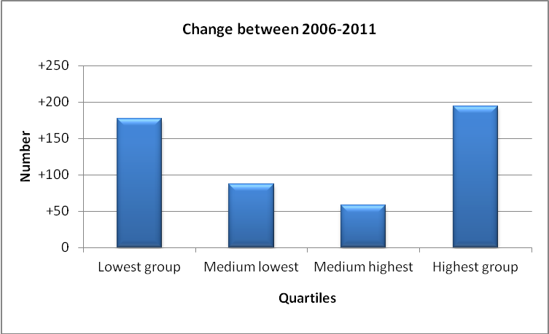
Source: ABS 2011 Census (Usual residence data) http://profile.id.com.au/hobsons-bay/home

Household incomes
At the 2011 Census, the median (midpoint) weekly household income in Australia was $1,234. Data for Williamstown shows the median household income was $1,587 which is well above the national figure and also the Hobsons Bay median of $1,286.

The graph below shows the income distribution of Williamstown households compared to Hobsons Bay. It illustrates that, overall, incomes in the neighbourhood are well above those of the municipality.

Williamstown has a lower percentage of households with incomes below $2,499 and a substantially higher percentage of those with incomes that are above that figure. Thirty one per cent of Williamstown households have a weekly income of $2500 and over compared to 19 per cent of Hobsons Bay households.

(NB: It should be noted that there was a high non response rate of 10 per cent to this Census question so the data should be treated with some caution.)

Graph 5: Household Income (weekly) for Williamstown
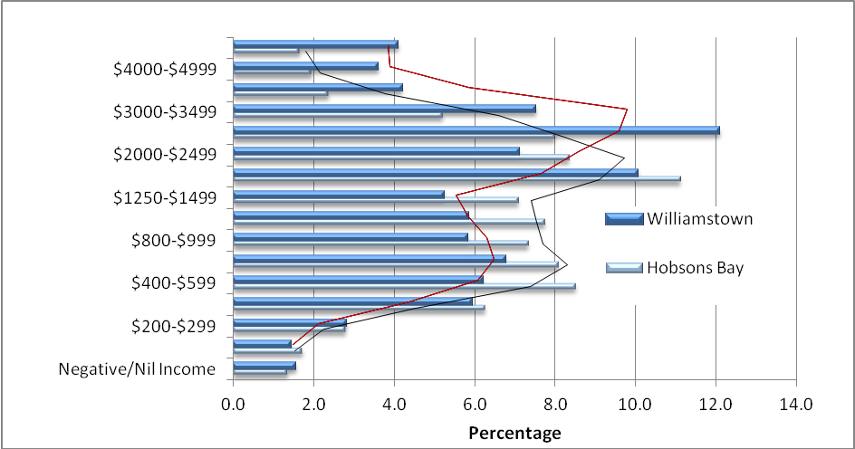
Source: ABS 2011 Census (Enumerated data) http://profile.id.com.au/hobsons-bay/home
As with individual incomes, household incomes are not comparable over different timeframes. As a result, the income quartile method used earlier is again applied here to compare changes in distribution of household incomes over time.

Graph 5 indicates that unlike individual income, household incomes rose substantially between 2006 and 2011. The largest change was in the highest quartile, which increased by just over 100 households. The number in the second highest quartile increased by 60 households while there was a decrease of 50 households in the lowest quartile.

Graph 5: Household income quartiles for Williamstown
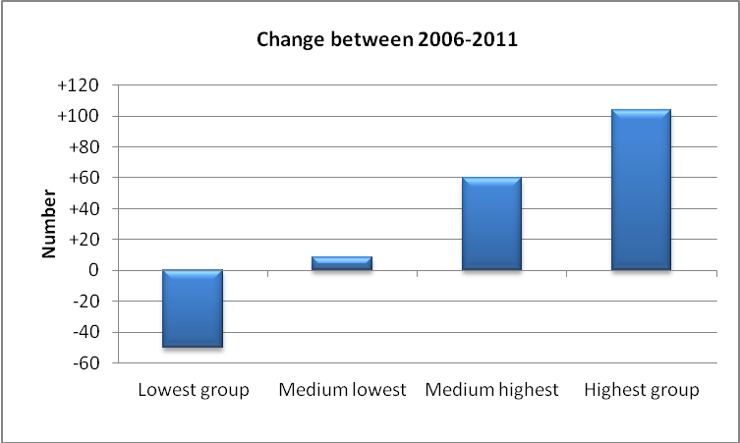
Source: ABS 2011 Census (Enumerated data) http://profile.id.com.au/hobsons-bay/home

Centrelink payments
Centrelink data is only available for the 3016 postcode which covers Williamstown (including the Rifle Range) and Williamstown North.

Residents receiving aged pensions make up the largest portion of Centrelink recipients in this postcode. A break down by the types of Centrelink payments at the March 2014 quarter is as follows:
- Aged pension: 1,316
- Disability support: 415
- Carers Allowance: 301
- Newstart: 343
- Single parenting payment: 81
- Youth allowance (other): 37
- Youth Allowance (student/apprentice): 115

In addition, 725 residents were in receipt of a health care card and 243 held a low income card.
(Centrelink March quarter 2014 http://data.gov.au/dataset/dss-payment-demographic-data)

SEIFA index of disadvantage
The Socio-Economic Indexes for Areas (SEIFA) disadvantage index is produced by the Australian Bureau of Statistics (ABS) and is drawn from Census data. The disadvantage index takes into consideration factors such as low income, high unemployment, jobs in relatively unskilled occupations, and low educational attainment. These are then aggregated into a single score.

The Australian average score is set at 1,002. Scores below that figure represent increased disadvantage and conversely those above indicate less disadvantage.

The SEIFA disadvantage score for Williamstown is 1062, which is well above the Australian benchmark and also the Hobsons Bay score of 1002. It is ranked second least disadvantaged neighbourhood among the municipality’s 11 neighbourhoods.

Table 20: SEIFA index of disadvantage ranking (2011) within Hobsons Bay
 | Disadvantage Score
Laverton | 891
Altona North | 910
Brooklyn | 947
Altona Meadows | 981
Hobsons Bay City | 1,002
Altona - Seaholme | 1,019
Spotswood - South Kingsville | 1,024
Seabrook | 1,031
Williamstown North - The Rifle Range | 1,058
Williamstown | 1,062
Newport East | 1,087
Source: ABS 2011 Census http://profile.id.com.au/hobsons-bay/home

Gambling losses
Within the municipality, residents have access to ten gambling venues, with a total of 577 Electronic Gaming Machines (EGMs/pokies) operating. Hobsons Bay currently has a cap on the number of EGMs that can operate in the city and this allows no more than 579 machines.

The financial impact of gambling on EGMs by Hobsons Bay residents in 2014-15 was substantial. A total of $46 million or $662 per adult was lost in the municipality, although it should be noted that losses have trended down over the last couple of years. Ranked against other local government areas in Victoria, Hobsons Bay is 22th in terms of the number of gaming machines per adult and 19th in terms of losses per adult.

Focussing on the three venues in Williamstown (Williamstown RSL, Victoria Inn and the Rifle Club hotel), $6,874,712 was lost in 2014-15 or 15 per cent of total losses in the municipality (Source: City of Greater Dandenong, Statistical Data for Victorian Communities, Gambling).

Council commissioned the 2014 Hobsons Bay Annual Community Survey and asked residents “Do you believe the number of pokies in the local area is too few, about right or too many?” One hundred and sixty residents of Williamstown and Williamstown North participated. Fifty-six per cent indicated there were too many EGMs, 19 per cent thought the number was about right and 25 per cent could not say.

The survey also asked residents, “What impact do you believe poker machines have on the Hobsons Bay community?” The findings show that just over three quarters of Williamstown and Williamstown North residents feel they are either very harmful or harmful. Eleven per cent of residents thought they were neither harmful nor harmless, three per cent thought they were somewhat positive and a further 10 per cent could not say.

- Housing

Dwelling types
There are 4,656 private dwellings in Williamstown. Just over 60 per cent are separate houses; the remainder are a mix of medium density housing (30.6%) and some higher density (7.1%).

When compared to Hobsons Bay as a whole, the neighbourhood has a much lower proportion of separate housing (13.7% less) and a larger proportion of high density stock (approximately 6% more), largely made up of two public housing tower blocks.

Table 21: Private dwelling types
 | 2011 |  |  | 2006 |  |  | Change  2006-2011
 | Number | % | Hobsons Bay % | Number | % | Hobsons Bay % | Change  2006-2011
Separate house | 2,862 | 61.5 | 75.2 | 2,878 | 63.6 | 75.8 | -17
Medium density | 1,424 | 30.6 | 22.7 | 1,301 | 28.7 | 22.4 | 123
High density | 331 | 7.1 | 1.4 | 287 | 6.3 | 1.1 | 44
Caravans, cabin, houseboat | 0 | 0 | 0.4 | 0 | 0 | 0.3 | 0
Other | 36 | 0.8 | 0.3 | 60 | 1.3 | 0.5 | -24
Not stated | 3 | 0.1 | 0 | 0 | 0 | 0 | 3
Total Private Dwellings | 4,656 | 100 | 100 | 4,526 | 100 | 100 | 129

Public housing stock
There are 346 dwellings in Williamstown that are owned by the State Government and the majority of these provide one and two bedroom accommodation. Public housing makes up just over six per cent of the total housing stock in Williamstown. This compares to the Hobsons Bay figure of three per cent.

Table 22: Public housing stock by bedroom number in Williamstown
Bedsit | 1 Bedroom | 2 Bedrooms | 3 Bedrooms | 4 Bedrooms | 5 Bedrooms | Total
4 | 141 | 127 | 72 | 2 | 0 | 346
Source: Dept of Housing (2014) requested data

As mentioned previously, there are several high-rise towers in Williamstown and as the table below shows, over half of all its public housing is located in high-rise flats.

Table 23: Type of public housing in Williamston
High-rise flats | Low-rise flats | Medium Density | Separate
180 | 43 | 123 | 0
Source: Dept of Housing (2014) requested data

Residential aged care
There is one residential aged care facility in Williamstown providing accommodation for 60 residents. In addition there is one transitional care facility.

Building permits
In 2013-14, 32 permits covering a total of 54 new dwellings were issued for suburb of Williamtown (includes Williamstown North and the Rifle Range). Seventeen permits were for detached housing, eight were for dual occupancy and three were for developments of three or more units or townhouses one of which was a larger development of 19 units.

Four commercial permits were also issued for the construction of retail spaces and warehouses.

Housing tenure
Approximately 34 per cent of Williamstown households own their own home, 32 per cent have a mortgage and a further 29 per cent are renting. Since the 2006 Census, this tenure pattern has been relatively stable with only a small increase in households with a mortgage.

The main difference in tenure patterns, compared to those of Hobsons Bay, is a higher proportion of households renting in social housing, as mentioned previously.

Table 24: Housing tenure of households (occupied dwellings)
 | 2011 |  |  | 2006 |  |  | Change  2006-2011
 | Number | % | Hobsons Bay % | Number | % | Hobsons Bay % | Change  2006-2011
Fully owned | 1,435 | 34.2 | 35.0 | 1,447 | 34.8 | 36.1 | -12
Mortgage | 1,338 | 31.9 | 31.4 | 1,247 | 30.0 | 31.4 | +91
Renting | 1,212 | 28.9 | 27.0 | 1,217 | 29.3 | 24.9 | -6
Renting - Social housing | 268 | 6.4 | 3.0 | 290 | 7.0 | 3.2 | -22
Renting - Private | 917 | 21.8 | 23.5 | 901 | 21.7 | 21.2 | +16
Renting - Not stated | 27 | 0.6 | 0.5 | 26 | 0.6 | 0.6 | +0
Other tenure type | 26 | 0.6 | 0.4 | 22 | 0.5 | 0.4 | +4
Not stated | 188 | 4.5 | 6.2 | 227 | 5.5 | 7.1 | -39
Total households | 4,199 | 100.0 | 100.0 | 4,160 | 100.0 | 100.0 | +39
Source: ABS 2011 Census (Enumerated data) http://profile.id.com.au/hobsons-bay/home

The cost of housing
The graphs below provide median monthly sale prices for houses and units in Williamstown over the 10 months to January 2015 (The median price is the midpoint of each month’s sales). The data suggests that prices for houses and units have remained fairly stable over that period with house prices just under $1 million and units around $500,000.

Between 2008 and 2014, the median house price rose from $590,000 to $950,000 and unit prices from $350,000 to $525,000.

NB: this data is for the Williamstown postcode 3016 which includes Williamstown, Williamstown North and the Rifle Range.

Graph 6: Trend data - Median house and unit prices
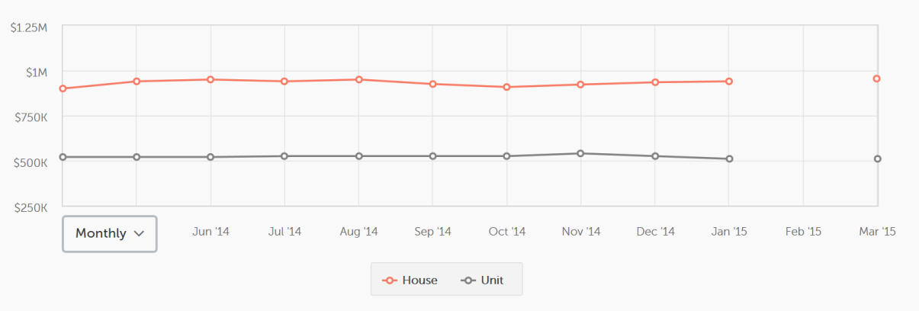
Source: http://www.realestate.com.au/neighbourhoods/williamstown-3016-vic (March 2015)

The figure below looks at the cost of house purchases and rents in March 2015 and shows the median price of $955,000 for the twelve months to 31 Jan 2015, with prices from just over $700,000 for a two bedroom house and $1,210 million for a four bedroom house. Median rents for the same period were $540 per week, ranging from $430 for 2 bedrooms through to $693 for four bedrooms.

Figure 7: Houses – purchase and rental in Williamstown
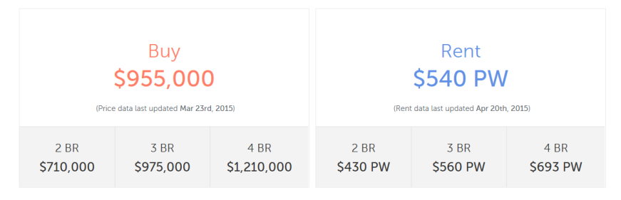
Source: http://www.realestate.com.au/neighbourhoods/williamstown-3016-vic (March 2015)

For the 12 months to 31 Jan 2015, the median price for unit purchases was $510,000. There were no one bedroom units sold in that period; the median cost of two bedroom housing was $472,000 and three bedrooms were substantially higher at $770,000.

The median rent for units was $360 per week, ranging from almost $280 through to $580, depending on the number of bedrooms.

Figure 8: Units – purchase and rental for Williamstown
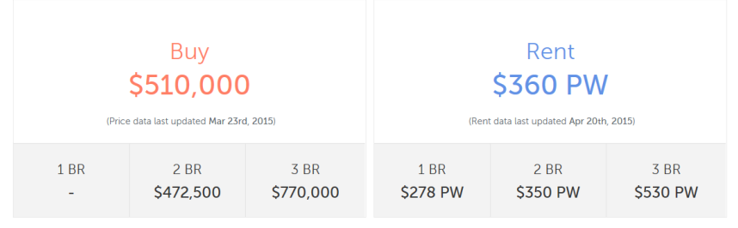
Source: http://www.realestate.com.au/neighbourhoods/williamstown-3016-vic (March 2015)

Housing mortgages
The monthly mortgage payments of Williamstown households are well above those for Hobsons Bay. For example, 54 per cent have monthly payments of $2,000 or more, compared to the municipal figure of 42 per cent.

Consequently, a lower percentage of households in Williamstown have monthly mortgages below $2,000. Twenty four per cent pay between $1,000 and $2,000 a month, compared to 35 per cent of Hobsons Bay households. The difference between those with mortgages below $1,000 is less pronounced (Williamstown 13%; Hobsons Bay 16%).

Graph 9: Monthly housing loan repayments (households)
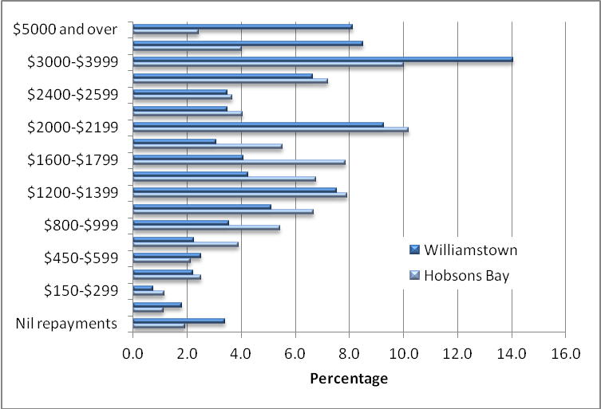
Source: ABS 2011 Census (Enumerated data) http://profile.id.com.au/hobsons-bay/home

Like incomes, comparing changes to housing loan repayments over time is difficult due to the impact of economic changes such as inflation and interest rates. By using quartiles, the data can be standardised to enable comparisons to be made across timeframes.

Despite the rise in house prices in Williamstown, it is interesting to note that there was a decrease in the proportion of households in the two highest quartiles and a corresponding increase in the two lowest quartiles. One possible factor for this may be that a growing proportion of households have paid down enough of their mortgage to reduce their monthly payments.

Graph 10: Loan repayment quartiles
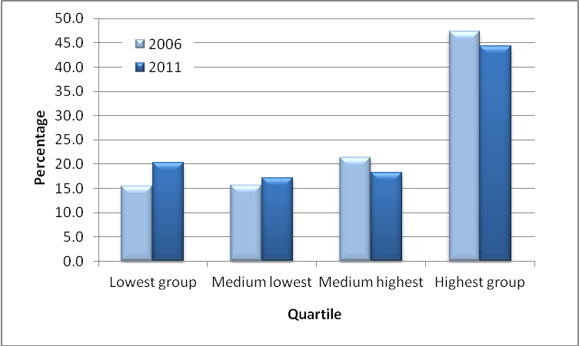
Source: ABS 2011 Census (Enumerated data) http://profile.id.com.au/hobsons-bay/home

Housing stress
Hobsons Bay City Council commissioned id.consulting to assess the extent of housing stress across the municipality and its neighbourhoods. Housing stress refers to the percentage of a household’s income that is required to cover rental or mortgage payments. A common definition of housing stress is when the household income is in the bottom 40 per cent of the standardised income are spending 30 per cent or more on housing.

Households on middle incomes who earn between 40 per cent to 60 per cent of the standardised income and also paying 30 per cent or more on housing are described as being in marginal stress.

id.consulting’s analysis found that just over seven per cent of Williamstown households (300) are in housing stress and three per cent of households (121) are in marginal stress, both were slightly lower compared to Hobsons Bay (9.5% low income households are in housing stress and 3.3% are in housing stress).

Breaking this data down further reveals that renting households are experiencing much higher levels of housing stress and this particularly applies to low income households. In Williamstown, one in five households who are renting (20%) are in housing stress well above the six per cent who are in marginal housing stress. The comparable figures for Hobsons Bay are 22 per cent and five percent.

Analysis of households with mortgages shows that 5.9 per cent of households are in mortgage stress and 3.8 per cent are in marginal stress which is below Hobsons Bay levels (10.1% and 5.6 % respectively)

- Transport

Car ownership
Based on responses to the 2011 Census, 84 per cent of households in the neighbourhood are car owners, which is in line with the municipal rate.

Looking at the number of cars that are owned, Williamstown households are reasonably similar to those across the municipality, with a similar proportion owning one car (37%), a slightly higher proportion owning two cars (36%, 2% more than the municipality) and a lower proportion owning three cars (8%, 2% less compared to Hobsons Bay).

The proportion of Williamstown households who do not own a car is marginally higher than the municipal rate(Williamstown 10.8%; Hobsons Bay 9%). However comparing 2011 and 2006 data, the proportion of the neighbourhood households without a car has dropped slightly, while car ownership has risen slightly across all categories.

Table 25: Car ownership
Williamstown | 2011 |  |  | 2006 |  |  | Change  2006 -2011
Number of cars | Number | % | Hobsons Bay % | Number | % | Hobsons Bay % | Change  2006 -2011
No motor vehicles | 453 | 10.8 | 9.0 | 510 | 12.3 | 9.8 | -57
1 motor vehicle | 1,566 | 37.4 | 37.5 | 1,528 | 36.8 | 36.6 | +38
2 motor vehicles | 1,506 | 36.0 | 34.2 | 1,464 | 35.2 | 34.1 | +42
3 or more motor vehicles | 448 | 10.7 | 12.8 | 391 | 9.4 | 11.9 | +57
Not stated | 213 | 5.1 | 6.5 | 262 | 6.3 | 7.6 | -50
Total households | 4,185 | 100.0 | 100.0 | 4,155 | 100.0 | 100.0 | +30
Source: ABS 2011 Census (Enumerated data) http://profile.id.com.au/hobsons-bay/home

Journey to work
Table 26 provides an overview of how people get to work and shows that the car is the dominant form of transport both in Williamstown and across the municipality.

Almost 60 per cent of residents either drive to work or are car passengers, which is lower than the Hobsons Bay figure of 66 per cent. While there was a small increase in the number of Williamstown residents who travel by car between 2006 and 2011, proportionately the figure decreased by around three per cent.

Fifteen per cent of the neighbourhood’s workers catch the train to work, marginally above the Hobsons Bay rate of 14 per cent. This trend has increased since the 2006 Census, both numerically and as a proportion of the population.

In terms of other modes of transport, a higher slightly proportion of Williamstown residents either cycle or walk to work or work from home, compared to Hobsons Bay.

Table 26: Main method of travel to work
 | 2011 |  |  | 2006 |  |  | Change  2006-2011
 | Number | % | Hobsons Bay % | Number | % | Hobsons Bay % | Change  2006-2011
Train | 820 | 15.4 | 14.1 | 614 | 12.4 | 11.2 | +206
Bus | 16 | 0.3 | 1.4 | 23 | 0.5 | 1.1 | -7
Tram or Ferry | 0 | 0.0 | 0.1 | 6 | 0.1 | 0.1 | -6
Taxi | 3 | 0.1 | 0.2 | 6 | 0.1 | 0.2 | -3
Car - as driver | 2,984 | 56.2 | 61.2 | 2,918 | 59.0 | 63.1 | +66
Car - as passenger | 192 | 3.6 | 4.6 | 184 | 3.7 | 5.0 | +9
Truck | 2 | 0.0 | 0.6 | 9 | 0.2 | 0.8 | -7
Motorbike | 18 | 0.3 | 0.5 | 34 | 0.7 | 0.6 | -16
Bicycle | 146 | 2.7 | 1.3 | 75 | 1.5 | 1.1 | +70
Walked only | 255 | 4.8 | 1.7 | 207 | 4.2 | 1.7 | +48
Other | 40 | 0.8 | 0.8 | 36 | 0.7 | 0.7 | +4
Worked at home | 281 | 5.3 | 3.0 | 226 | 4.6 | 2.7 | +55
Did not go to work | 497 | 9.4 | 8.9 | 532 | 10.7 | 9.8 | -34
Not stated | 54 | 1.0 | 1.7 | 79 | 1.6 | 2.0 | -25
Total employed persons aged 15+ | 5,309 | 100.0 | 100.0 | 4,949 | 100.0 | 100.0 | +360
Source: ABS 2011 Census (Enumerated data) http://profile.id.com.au/hobsons-bay/home

- Population Forecasts

Population numbers
Population forecasts for Hobsons Bay and its neighbourhoods are informed by the results of the 2011 Census. These figures are then adjusted to incorporate information such new residential development, together with population trends related to births, deaths and internal and external migration. The forecasts are developed for Council, by id.consulting.

As noted earlier, the population of Williamstown increased by 420 people (+4%) between 2006 and 2011. The table below provides forecast data for the coming decade and shows a growth rate of 20 per cent through to2025 (2,271 new residents).

However the bulk of that increase is expected between 2015 and 2020, after which it should return to a figure of around four per cent.

Table 27: Population forecasts
 | 2015 | 2020 | 2025 | Change 2015-2025
Total Persons | 11,377 | 13,031 | 13,648 | 2,271
 |  | 14.5% | 4.7% | 20.0%
Source: http://forecast.id.com.au/hobsons-bay?WebID=10

The forecasts suggest that over the next five years almost all age groups, apart from those aged 85 years and over, are expected to increase.

After 2020, that increase is forecast to slow among most age groups, apart from the age ranges between 60 years and 84 years.

Graph 11: Forecast age structure
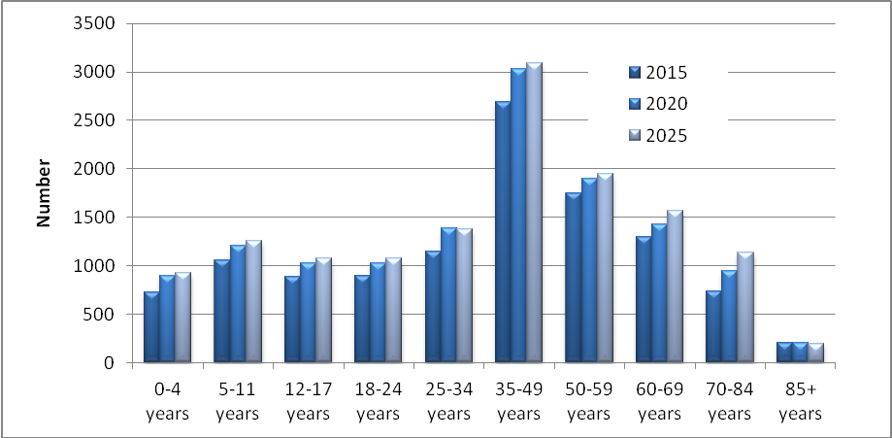
Source: http://forecast.id.com.au/hobsons-bay?WebID=10

The graph below helps to further illustrate changes in the age structure over the coming decade and highlights an ageing trend in the longer term.

It shows higher level of growth in the five years to 2020 across all age groups up to 85 years, as noted above. Thereafter growth in most age groups slows markedly except among those between 60 and 84 years.

Graph 12: Changes in age structure between 2015-2025
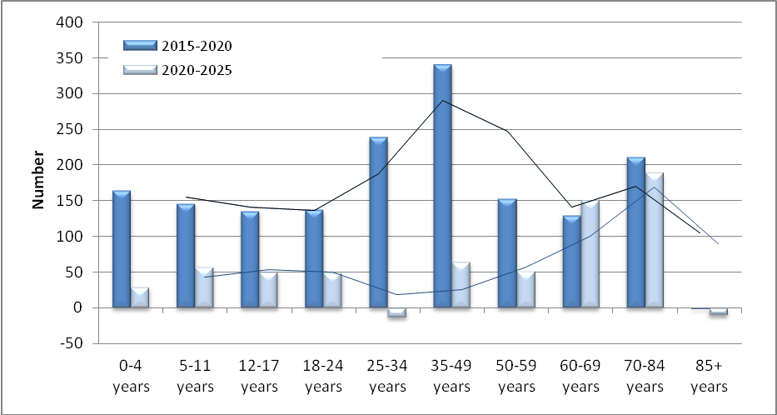
Source: http://forecast.id.com.au/hobsons-bay?WebID=10

Housing and household forecasts
The population forecasts anticipate that approximately 933 new dwellings will be constructed in Williamstown over the next 10 years; development of the former Port Phillip Woollen Mills is expected to be a major contributor. As a result, approximately 848 new households will make the neighbourhood home.

Along with larger population growth between 2015 and 2020, the average household size is expected to increase from 2.51 to 2.54, in line with the increase in the number of children over that period, before dropping back to 2.52 after 2020. By 2025, the average household size will be below the Hobsons Bay average of 2.55 people.

Table 28: Future housing and households
 | 2015 | 2020 | 2025
Average household size | 2.51 | 2.54 | 2.52
Dwellings | 4782 | 5412 | 5715
Households | 4493 | 5058 | 5341
Source: http://forecast.id.com.au/hobsons-bay?WebID=10

Graph 13 highlights the forecast changes in the types of households in Williamstown and reinforces the age structure changes mentioned above.

Up until 2020, the largest increase is expected among households with dependants, followed by couples without dependants and lone person households. Thereafter, the number of these households will continue to grow, although growth among households with dependents will be lower.

Graph 13: Change in household types between 2015 and 2025
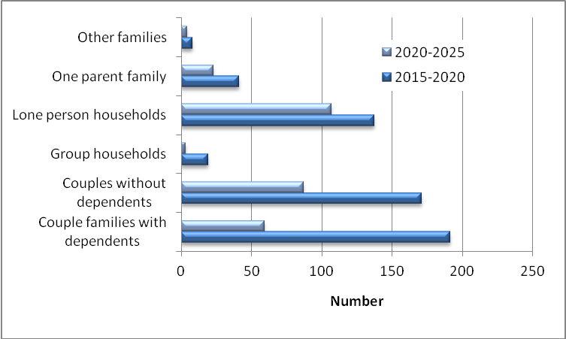
Source: http://forecast.id.com.au/hobsons-bay?WebID=10

DATA DISCLAIMER
Every care has been taken to ensure the information in this document is correct. However, Hobsons Bay City Council does not accept any liability to any person or organisation for the information (or the use of such information) provided in this document.

Appendix 1: Postcode Areas
Postcode 3016 includes the Williamstown and Williamstown North neighbourhoods.

NB This profile refers to the Williamstown neighbourhood only – refer page 5 for neighbourhood boundaries.

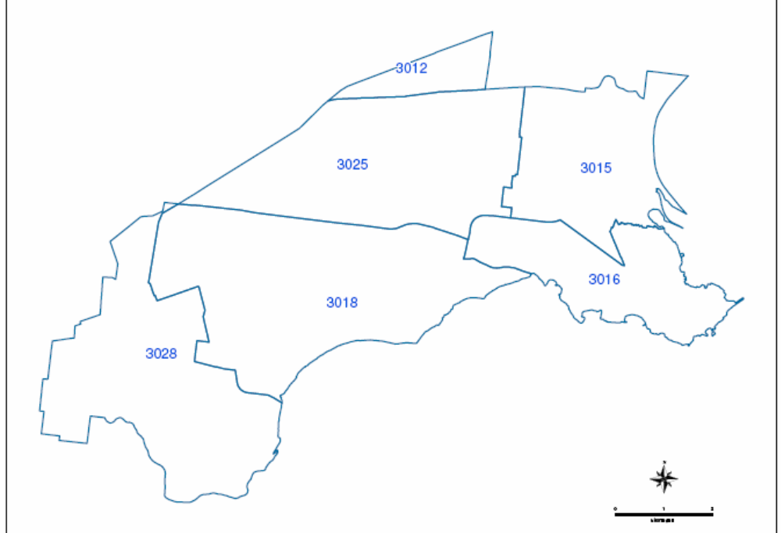

Williamstown neighbourhood
Consultations

A. Introduction
The Williamstown Profile is intended to provide an overview of the history and development of the area, some data about the characteristics of residents and information about the types of services and facilities available in the neighbourhood.

However, none of this information can describe how people feel about Williamstown as a place to live, visit or work. In order to gain a better understanding of these perspectives, a number of consultations took place in early 2009.

During the consultations, several long term residents also shared their memories of living and working in Williamstown and some of their comments are included towards the end of this consultation section.

B. Methodology
Several consultation methods were used namely focus groups, individual interviews and a survey.

A total of four focus group sessions were held. In order to ensure a variety of views were heard, participants in these discussions included a range of age groups, parents and people from non-English speaking backgrounds. Each session lasted for approximately one hour.

The focus groups included:
- Participants in a planned activity group for older people (PAG)
- Playgroup parents
- Grades 5 and 6 students from Williamstown Primary School
- English as a Second Language (ESL) students

Five people were interviewed individually or in a small group and a survey was sent to the members of the Williamstown Chamber of Commerce.

(The questions used in the consultations are included in Appendix 1.)

C. Findings
How would you describe Williamstown?
A recurring description of the Williamstown neighbourhood is that it is buffered from the hustle and bustle of suburban life. The physical geography of the area plays an important role in creating a sense of being “tucked away”. Williamstown is surrounded on two sides by water and while it is an attractive destination point for visitors, it is generally not impacted by passing traffic. A couple of long term residents spoke positively about the location, “I look out of my house and see water which gives Williamstown a sense of isolation and a village feel” and “It’s a mix of being a country town and a seaside town. It’s a place that you want your kids to grow up in and the proximity to the beach gives it a holiday feel.”

The contained nature of Williamstown was also a positive feature for younger children involved in the consultation and they talked about having a sense of freedom and independence.
It’s not too big. You know where you are, so it’s easy to find your way about.
I’d never get lost in Willie… I always know where I am.
My parents don’t get worried because it’s small. In bigger places my parents would be checking where I was.

Because they were familiar with the area, children saw Williamstown as being a physically safe place, strengthened by the fact that they knew and were recognised by local residents. They talked about knowing their neighbours and of sometimes knowing people’s faces but not always their names. “It’s got its own little community. Everyone knows everyone.”

In describing Williamstown, one young student said “It’s got history” and talked about areas related to its early settlement, such as Point Gellibrand. Williamstown’s history was one of the factors that attracted a more recent arrival to the neighbourhood who relocated from the inner city after living there for 30 years. “I’m interested in history. I didn’t really know Williamstown existed. But I had friends in the west and came over the Westgate and found Williamstown”.

Longer term residents described the neighbourhood as a place that is changing, as new residents are attracted to the area. “The Williamstown I knew was a place where everyone knew each other. It was a social experience but now it’s more about the individual.” Another person noted the changing demographic. “When I first arrived it was definitely more working class, but that’s changed.”

Along with these changes in the population, people also talked about their attachment to the physical character of the area and of wanting to protect the characteristics that make Williamstown unique. “I want it to keep its seaside feel – smaller and simpler – not like a millionaires’ row, not like the St Kilda marina.”

What makes it a good place to live and work?
Residents of Williamstown spoke positively about living in an area where there was a strong sense of community and open friendliness among the locals. One person commented that “walking down the street, people talk and say hello. This is a very close neighbourhood. I know everyone in the street and we chat – sometimes you have to avoid people!” Another person mentioned the long term friendships that had formed when a number of the women in her street were at home caring for children. “There was lots of interaction through childminding, borrowing and socialising. Some of the families in the street used to holiday together. We used to have street parties but these became too expensive when charges for street parties were introduced.”

Initially attracted to the community and the village feel of Williamstown, a former resident said that “having lived in Melbourne for 10 years, it was the first time I knew my neighbours. You met people because they’re out and about on the street”. A newer resident had clear criteria for choosing to live in Williamstown. “I wanted to buy into an area that had a sense of community, a mixture of age groups, but I also wanted to be able close the door and be private. I also like that there is social housing here and I was surprised that several shops were running a slate for pensioners who couldn’t afford to pay till the next pension. All this mixed in with social housing!” However, alongside an appreciation for the strength of the local community, there were concerns about changes in the area. According to one person, rising housing costs had changed the demographic of Williamstown residents and as a result there was a “snobbishness among some residents”.

As mentioned earlier, the fact that Williamstown is not affected by passing traffic was regarded as a really positive aspect of the area. One person who had previously lived in a congested inner suburb commented, “I was surprised about the lack of through traffic because noise pollution bothers me.”

People were also appreciative of living near the beach, although for different reasons. While enjoying being close to the sea, a former resident commented, “I didn’t swim much but the proximity to the water and the open space was calming”, others were more actively engaged. “Our focus is on sailing more than on the beach and swimming. All the family are involved in sailing and we’ve made good friendships through it. ” Along with enjoying visits to the dog beach, children spoke about discovering the nooks and crannies at the beach and described “a secret spot with a little bit of sand – good for little kids, it’s safe, it’s really shallow and then it gets deep. It’s got rocks so there aren’t any waves.”

As a result of living near the sea, people listed a range of activities they enjoyed including ocean swimming, cycling and walking along the beach and its environs. However, the popularity of the beach had some downsides, “often in summer it’s too crowded so I use it [the beach] after hours.”

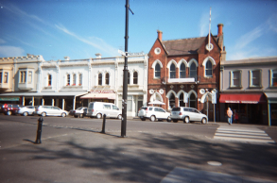
Apart from the beach and the variety of sports
Source: Nelson Place, photo by Williamtown Primary
School student

and leisure activities they’re involved in, students at the local primary school enjoyed the Nelson Place precinct. “Nelson Place is a mix of shops and restaurants but not crammed. It’s like an outdoor shopping mall.” They particularly liked the ice-cream shop and restaurants located there.

Elderly residents felt that Williamstown provided them with a secure base. It was a place that was familiar, “where you know people” and have established friendships and routines. They spoke about having good neighbours they could call on. They also enjoyed having access to places such as the senior citizens which provided the opportunity to socialise. One person was a great walker, despite requiring a walking frame, and enjoyed the social interaction and exercise it provided.

Other positive features of living in Williamstown were that “it’s only about 20 minutes from everywhere” and “it’s close to the city and Highpoint but far enough away from everything too”. People felt that it was a safe neighbourhood. As mentioned early, children felt confident about their personal safety and this view was supported by others. “I go to bed with the doors unlocked and generally feel safe walking about.” Other people mentioned that while the area had experienced its share of burglaries and occasional violence, they believed that these were random events rather than the norm.
What things do you do locally and what local facilities do you use?

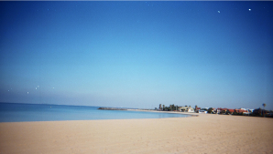
Younger children were involved in a broad range of activities, predominantly sporting, in the local area. A number of these activities were centred on the beach and included participation in a cold water swimming program and the nippers group at the Life Saving Club, snorkelling and sailing, together with fishing off the pier near Nelson Place. Some played team sports including basketball, football, cricket, tennis and lacrosse as part of the school program and also outside of school hours. Involvement in scouts was also mentioned.
Source: Williamstown Beach, photo by Williamtown Primary School student

Beach related activities were also popular with families. As mentioned earlier, sailing played an important role in the leisure and social life of some. Parents of younger children looked forward to them joining the nippers program when they were a little older and generally felt there were plenty of activities for their children. That said, they acknowledged that the costs associated with some activities might be an issue for some families.

People’s shopping preferences varied markedly. One person said that most of their shopping was done locally, except for ‘one off’, larger purchases which tend to be made at larger centres such as Highpoint. According to another, “I predominantly shop locally. I do go to Footscray market but buy groceries, clothing, gifts here.” Some people tended to spread their shopping. “I use the local supermarket and butcher and also shop at the Victoria Market and at Altona Gate. In relation to clothing, Williamstown tends to be upmarket and pricey and doesn’t have ‘everyday’ clothes.”

The cost and variety of shops influenced how some people shopped. A former resident said “I did nearly all of my shopping locally with a shopping jeep. It [Williamstown] has most of the things you need – maybe not at the cheapest price. Otherwise, I tended to shop at Highpoint because it’s cheaper and with clothing there’s more of a selection. Williamstown tends to be more upmarket with higher quality boutiques.”

Students attending an English as a Second Language (ESL) class in Williamstown but who were not necessarily residents of the neighbourhood mainly did their shopping in Altona North, Altona Gate and Footscray. Most noted that price was an important factor that influenced their shopping. They also mentioned that shopping in Footscray gave them better access to a wider variety of food items.

The places where children said they and their families shopped included the Victoria & South Melbourne markets. They also patronised the local sweet shops! While some of their clothing was bought locally, they shopped “mainly at Highpoint and sometimes in the city and at the DFO [direct factory outlet]. Williamstown is generally more for adult clothes”. Describing their shopping experience, some of the older participants at the consultation commented that “the shops and shopping area aren’t geared up for older people”.

On another tack, one parent spoke very positively about the local traders who provided employment for young people. “One [of my children] has a job at a local shop – it’s a good thing that local traders look after the local kids. Lots of my friends’ kids also have a local job.”

People in the consultations were asked about the local health services they used. A few attended doctors in Williamstown, “I tend to go wherever you don’t have to queue. It’s sometimes hard getting in at Williamstown - there’s long waiting lists” and “I use the local doctor and generally don’t have to wait, probably because it’s usually not urgent.” The hospital was also used occasionally, particularly for emergencies, and as one person said, “I hope that it stays”.

The library was another service used by residents. Parents of young children used both the library and the toy library. One parent with teenage children said “the kids use the local library and we’re looking forward to the new library – it will make it a lot more attractive and inviting”. One resident who used the library was more critical about the service. “I use the library less so now than I used to. It used to have reasonable stock but the range is not so good now. I support the library but it’s a pity that all the history books are reference books and so can’t be borrowed, and it has very small resources in it.”

People also talked about their involvement in social activities in Williamstown. As mentioned earlier, participants in the planned activity group (PAG) enjoyed the opportunity to socialise, especially those who had disabilities and were generally reliant on the support of a carer. For those still living with parents or who were in assisted living facilities, the PAG played an important role. Some residents were members of clubs, including the local RSL and the film society. Other social activities people attended were music events such as the Sounds of Summer festival or live music on offer in local pubs around Williamstown.

What things do you regularly do outside the neighbourhood?
Sport was an activity that many people participated in outside the Williamstown neighbourhood. In most instances, this happened in other parts of the Hobsons Bay or nearby municipalities. Both adults and school children said they played in team sports such as football, tennis, hockey and baseball and one child also attended training in gymnastics and swimming.

Shopping, as mentioned previously, was an activity regularly undertaken outside the neighbourhood. Among the most popular shopping destinations were the larger retail centres in the western suburbs and also central Melbourne, where people said they could obtain a wider variety of goods and where prices were sometimes lower.

A number of people who participated in the consultation used health services outside of Williamstown. People travelled to doctors and dentists in nearby suburbs or in areas where they had lived previously. In some instances, people travelled because they were keen to maintain relationships with a long-term health provider, while others noted the difficulty of getting appointments in Williamstown, particularly with doctors.

Several parents spoke about their children travelling to attend school outside the area. Another indicated that while her children attended local schools, she had a number of friends whose children travelled to schools in other parts of Melbourne. On the whole, the children who participated in the consultation indicated that they would be attending secondary schools in areas outside the municipality.
As to be expected, socialising was an activity that regularly occurred in other places, although this was sometimes due to a lack of local friendships and networks. According to one newer resident, “I don’t have many close friends or family here so that takes me away and if you don’t have children, you’re not in the school network”.

Getting about the neighbourhood.
Being a reasonably flat area and with mostly local traffic on the roads, Williamstown was considered to be a very walkable neighbourhood. Walking was regularly mentioned as an enjoyable and practical method for getting about and also for keeping fit. Residents talked about “walking to places to meet friends and because I don’t do a [large] weekly shop, it’s easy to walk”. Several young parents commented that walking was their preferred method for getting around Williamstown and that it was an easy place to get around with young children.

Others combined walking and cycling as transport options. “We cycle to the beach for a swim and catch the punt when it’s operating. Sometimes to supplement a big shop, we walk down to Douglas Parade. It would be more rare to take the car because I tend to buy little loads.”

Children from the local primary school used multiple transport methods for getting about. Most said they were rarely driven to school because they live close by and only went by car if it was too wet or they were running late. The majority of children walked to school and some also rode bikes, scooters or skated. While adults tended to see the roads as reasonably safe to navigate, children were concerned about traffic, especially buses, and as a result they “hardly ever ride on roads, only in quieter streets”. Those who cycled said they generally rode on paths, pointing out that they worried about hitting pedestrians. In terms of getting to after-school activities, the children said they usually walked or rode, but if they had a lot to carry or some distance to travel their parents drove them by car.

In the main, people who participated in the PAG consultation were elderly and had a disability. As a result, they tended to use taxis or were dropped off by car. One person, mentioned earlier, who despite needing a walking frame was an active walker as a means for getting about and keeping active.

A number of people spoke about being regular public transport users. “I use public transport two or three times a week but I walk to Newport to get the train [rather than Williamston station] because you’re on two lines. I wouldn’t drive the car to the city.” The changeover at Newport station, in order to catch the Williamstown train, was a disincentive to one person. “The introduction of a train shuttle meant changing trains at Newport [to connect with the Williamstown train] and discouraged me from using it. I didn’t like waiting by myself at Newport, at night.”

While safety and regularity of services were issues for some public transport users, others said they would “ like to use it more but it comes down to cost – it’s more expensive than driving and it makes it prohibitive.” People also mentioned public transport “services don’t generally run where I need them”. Students in the ESL classes felt that access to public transport was generally good, although buses on the Sunshine to Williamstown route tended to be unreliable.

Amongst those who worked reasonably close to home, transport options varied. Car use was common, but was often substituted with walking or riding a bike either on the road or on shared pathways when they were available.

What would make Williamstown a better place
Public infrastructure in Williamstown was identified as needing attention. According to one person “the condition of footpaths and crossings is pretty poor. The roads are potholed and cracked. It doesn’t affect me now but for older people there are a lot of trip hazards. Crossing some busy roads has got better but crossing in areas like Willie Road is difficult – there probably should be more refuges (traffic islands). The school crossing [in Williamstown Road] has the only set of lights”. The standard of footpaths was also an issue for children. “I really don’t like the footpaths. They’re bumpy and cracked and have broken glass all over them” …“if you’re on a scooter or rollerblades your wheels get stuck in the cracks”.

Better information about Williamstown and the local services was cited by a newer resident to the neighbourhood as an area for improvement. “I found it very hard to find things out when I first came. I asked the Council if I could go onto a mailing list to receive information about local happenings but there wasn’t one. I still get the local newsletter from where I used to live and I can’t believe the difference – it’s informative about what’s happening and it’s in three languages. I also asked at Council for a resident’s kit and was disappointed that there wasn’t one. We need good community information.”

A lack of doctors in the area was raised by a cross section of residents, resulting in long waiting lists for appointments or in some cases having to travel to other areas to visit a doctor. According to one newer resident, “Initially, I was horrified that there was no community health centre. I then looked for a female doctor and rang around six surgeries and was told that ‘you’ll never get onto female [doctors] books because they’re all closed’ - so I’m still travelling to my previous doctor”.

Some transport issues, particularly public transport, have already been mentioned. Along with better access to public transport, the provision of a community bus was identified as lacking. “A community bus would mean older people could get down the street to shop - it would keep them independent.”

Despite feeling that the geography of Williamstown buffered the neighbourhood from passing traffic, residents who worked elsewhere and travelled by car were concerned about traffic congestion. The gridlock of getting on and off the Westgate Bridge was mentioned. Although the bridge does not fall within the neighbourhood boundary, it is the major road link to the CBD and the south east. Residents also felt that congestion on the Westgate Freeway was getting progressively worse and those who worked in places with poor links to public transport noted that there was no alternative but to use the bridge.

Along with traffic congestion, residents had a number of concerns about the impact of Williamstown’s growing popularity as a place to live. “My husband grew up in Hobsons Bay and it was his dream to live in Williamstown, however he is concerned about the need to upgrade infrastructure to meet increased demand.” People also noted a need to manage this change in order to protect what made the area. “Williamstown has changed – it’s more popular and also more expensive and this has changed the feel of the place. There has been inappropriate development, particularly along the Strand where there are only a few of the original houses left.”

This tension of managing development and the change it brings was also highlighted by those who had lived in the area for a long time. “I lived here before it became upmarket. I don’t like what’s happened along the Strand – there are some [housing] monstrosities. Planning regulations seems to be inconsistent. People with money get what they want.” Some older residents felt there was sometimes a lack of respect for “what’s already here and those who have lived here a long time” among the neighbourhood’s newer residents.

When asked what would make Williamstown a better place to live, one resident commented, “I’d like less tourists. They put demands on the local infrastructure, the parks get trashed, it’s hard to get into restaurants. The associated costs fall on the ratepayers. Traffic congestion on the weekends is bad. On nice days, traffic can be bumper to bumper. Might be part of the reason why locals don’t drive.”

Several safety concerns were raised by residents. Poor street lighting was identified as a hazard to people’s mobility and getting around the area, especially at night. For parents with young children, playground safety was important and they suggested better fencing and shading of playgrounds and parks were required.

Parents also expressed a need for better access to childcare and were concerned about long waiting lists at some centres. One working parent who wanted her child to attend a childcare centre that was collocated with a kindergarten had waited for three years for a place at the centre.

Participants in the consultation said they would like to see more diversity in the shopping centre. They talked about wanting a wider range in terms of prices, commenting that Williamstown “tends to be geared around money but poverty is there and it’s a fairly expensive place for shopping”. People also wanted a better mix of shops to suit the full age spectrum.

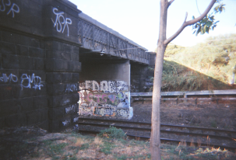
The state of the physical environment was a high priority among school students and they felt there was room for improvement. “Some areas look really nice and some areas just look horrible, there’s graffiti and the grass is dead”. They also talked about the neglect of land along the railway tracks where “there’s lots of rubbish.”
Source: Railway tracks, photo by Williamtown Primary
School student

The children were also concerned about public behaviour and the impact of vandalism, speeding cars “they’re really annoying”, and “hoons walking around late at night in summer and starting fights”.

Residents memories
One man in his 70s, who has been a long term resident of Hobsons Bay and Williamstown, spoke about having worked as a blacksmith at the former Williamstown dockyards for more than 40 years. He reminisced about how shipbuilding had changed over that time and how ships “used to be built from the ground- up” at the dockyards. He’d seen major changes in the shipbuilding process with the introduction of new technologies and the off-site manufacturing of component parts. This had resulted in the loss of jobs and had had a great impact on the neighbourhood as many of these workers were also local residents.

As previously mentioned, some people in the consultation were somewhat amused about changes in the general perception of Williamstown. They remembered the area being referred to as “an old folks home” and as “a dump”. One long term resident talked about the negative reaction of friends when told he was going to live in Williamstown. “They asked me why and if I knew what I was doing.” Several people commented that “if you lived in Williamstown you were looked down upon” but that this view had changed considerably and Williamstown was now seen as a desirable place to live.

Staying in Williamstown
There were a variety of responses as to whether people planned to live in Williamstown for the foreseeable future. For some, the thought of leaving was not an option to consider, “Nothing would make me move”. It was clear people had strong feelings about and commitment to Williamstown. “I see myself in Williamstown forever. I’d be broken hearted if I had to leave” and similarly, “I think I’m cemented. I wouldn’t leave if I stayed living in the city – I wouldn’t move to another suburb”.

One parent of young children indicated that while they were keen to stay in Williamstown, the future education of their children might mean leaving the area if they selected schools in other locations. Another parent had “no intentions of leaving” and said she loved the environment, that it was close to family and friends and she felt the area had all that was required to meet her family’s current and future needs.

One person who had been a resident for several years was pragmatic about staying in Williamstown. “It suits us at the moment. We didn’t buy a small house or a large one. Eventually it might get too large so we might have to down size again but I don’t know if that would be here.”

Choosing to remain in Williamstown had not been an option for a former resident who reflected on why she had reluctantly left Williamstown to live in another suburb. “I couldn’t afford to buy and I couldn’t afford the rent increases”.

Children who participated in the consultation generally felt that their parents liked the area and had no plans to move. One spoke confidently about his family staying put, “When we moved from Newport my mum hated the move and she’s not too keen to move again”.

Focus Group Questions
Appendix 1
What’s your connection with the area?

Local resident HB resident Work here Visitor Other___________________
Male Female
<20 years 20-35 36-55 >55

- If you were describing Brooklyn/Altona North what are some of the area’s distinctive features? (what makes it different to other places)

- What are the things that make it a good place to live / work / visit?
Prompts
- The facilities (eg parks, open space, leisure facilities)
- Access to shops; shops have what you need
- Access to services (doctors dentists etc, childcare/MCH, schools )
- Affordable housing
- Close to work
- Safe environment (walking about, after dark, in home)

- What sort of activities do you do locally?
Prompts
- Member of club / group
- Play sport
- Socialise / meet with friends
- Volunteer
- Shop
- Work

- What are some of the facilities you use in the local area?
Prompts
- Childcare/MCH/preschool/schools
- Sports/ recreation
- Neighbourhood
- Community centre/halls
- Seniors centre

- What things do you regularly do outside the area eg in other parts of Hobsons Bay or beyond?
Prompts
- library
- shop
- go to school
- access services health
- Sport/leisure activities
- Catch up with friends / socialise
- How do you normally get about the area?
Prompts
- public transport
- drive
- walk
- ride a bike)

Is it easy / safe to get about?

- What would make it a better place to live / work / visit?
Prompts
- sport/leisure places
- meeting /socialising opportunities
- transport
- shops
- services
- safety
- work

- Do you expect to still be living here in the next 5 years – if yes – how do you think your needs will change
- facilities
- services

