Information for parents with infants and young children
COVID-19 Victorian Maternal and Child Health service update
5 August 2020

In the changing coronavirus (COVID-19) environment, content is often being updated. To ensure you are aware of the most recent changes, all content updates and the date the document was last updated will be highlighted in yellow.

Maternal and Child Health care access is different
To help slow the spread of coronavirus (COVID-19) in the community, Maternal and Child Health (MCH) services have been providing services to families through alternative modes of delivery, including telephone or online consultations and face to face consultations.

State 4 Restrictions - Metropolitan Melbourne
Stage 4 restrictions apply to people living in metropolitan Melbourne. This means that:
- A curfew now applies across metropolitan Melbourne from 8pm to 5am. The only reasons to leave home during these times will be work (if you can’t do it from home), medical care and caregiving (including MCH services), safety reasons or in an emergency.
- New time, distance and gathering limits apply to shopping and exercise. Exercise will be limited to one hour a day within a five-kilometre radius of your home. Group size is limited to two people, whether you live with them or not.
- Shopping for essentials will be limited to one person per household per day. A five-kilometre limit from your home will apply, unless your closest supermarket is more than 5km away from your home, in which case you can go to your closest supermarket.
- Distance, gathering and time limits will not apply for work that cannot be done from home, medical care or compassionate reasons.
- For more information on Stage 4 restrictions please visit our website <https://go.vic.gov.au/FZ1vYJ>.
MCH services in Metropolitan Melbourne are different under Stage 4 Stay at Home restrictions.
To slow the spread of coronavirus (COVID-19), MCH service providers in metropolitan Melbourne during Stage 4 restrictions will:
  - Provide MCH services for all infants 0-8 weeks at each Key Age and Stage (KAS) visit, Aboriginal infants and children and those with additional needs or concerns including families on the Enhanced Maternal and Child Health Program.
  - Include alternative models of service delivery such as telephone and telehealth consultations supplemented by short face-to-face consultations to undertake physical and developmental assessment, weight checks and breastfeeding support.
- Undertake short face-to-face appointments for all 0-8-week KAS visits, Aboriginal infants and children and those with additional needs to supplement telephone or telehealth consultations.
- On the advice of the Chief Health Officer, from 8 July, all face-to-face group sessions held in metropolitan Melbourne ceased. Groups will be supported through telehealth and other virtual services where possible.
- Subject to staffing ability, KAS visits or consultations to children in older age groups from four months onwards, including alternative models of service delivery will also continue. Short face-to-face consultations will be scheduled for physical and developmental assessment and weight checks.
  - People who live in Metropolitan Melbourne under Stage 4 restrictions and are leaving home for one of the allowed reasons must wear a face covering, unless they have a lawful exception. Infants and children under the age of 12 are not required to wear a face covering. Due to the risk of choking it is not safe to use a mask or face covering on a child under two years of age.
Please contact your local MCH service for information on change of service delivery and remember the 24-hour Maternal and Child Health Line is always available on 13 22 29.

Restrictions Regional and Rural areas including Mitchell Shire
Regional Victoria is now under Stage 3 restrictions, where there are only four reasons to leave the house: care and caregiving, shopping for the things you need, exercise, and work and education – if you can’t do it from home.
MCH service providers in regional and rural areas will:
  - Provide MCH services for all infants 0-8 weeks at each Key Age and Stage (KAS) visit, Aboriginal infants and children and those with additional needs or concerns including families on the Enhanced Maternal and Child Health Program.
  - Include alternative models of service delivery such as telephone and telehealth consultations supplemented by short face-to-face consultations to undertake physical and developmental assessment, weight checks and breastfeeding support.
- Undertake short face-to-face appointments for all 0-8-week KAS visits, Aboriginal infants and children and those with additional needs to supplement telephone or telehealth consultations.
- On the advice of the Chief Health Officer, from 5 August, all face-to-face group sessions held in regional and rural areas will cease. Groups will be supported through telehealth and other virtual services where possible.
- Subject to staffing ability, KAS visits or consultations to children in older age groups from four months onwards, including alternative models of service delivery, will also continue. Short face-to-face consultations will be scheduled for physical and developmental assessment and weight checks.
- All people in Victoria must wear a face covering when they leave home. Infants and children under the age of 12 are not recommended to wear a face covering. Due to the risk of choking it is not safe for a child under two years of age to wear a face covering or face mask.
Please contact your local MCH service for information on change of service delivery and remember the 24-hour Maternal and Child Health Line is always available on 13 22 29.

For further information about coronavirus (COVID-19), visit the Department of Health and Human Services website: https://www.dhhs.vic.gov.au/coronavirus.

Face Masks and MCH Consultations
To slow the spread of coronavirus (COVID-19) the Chief Medical Officer has updated advice for all health care workers (including MCH nurses) in wearing personal protective equipment (including surgical face masks and eye protection) during face-to-face consultations.
- Health care workers must wear (at a minimum) a level 1 or type 1 surgical mask while at work. Cloth masks cannot be used at work. This includes during MCH consultations at a MCH centre or in a home.
- MCH staff who are treating clients must wear eye protection and a surgical face mask.
- You will be asked to wear a face mask during your face to face MCH consultation whether that is at a MCH centre or in your own home if a MCH nurse is visiting.
Children under two years should never wear a face mask due to choking and strangulation risks.

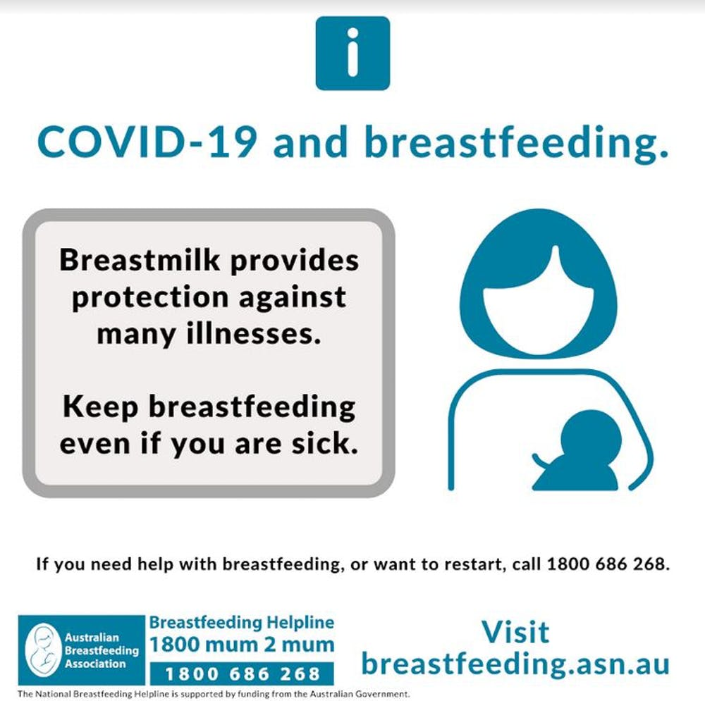
Feeding your baby

Breastfeeding
Many parents may have questions as to whether they should continue to breastfeed, especially if they are unwell.
Breast milk contains many ingredients to help prevent and fight infection. It is recommended babies be fed only breast milk until they are six months old and continue breastfeeding with other foods into their second year of life.
The latest advice from the Australian Breastfeeding Association is to keep breastfeeding, even if you are unwell: www.breastfeeding.asn.au/bfinfo/covid-19
If your baby is under six months and breastfeeding, offering them only breast milk protects them from a range of infections and reduces their need for medical treatment or hospitalisation.
If your baby is breastfeeding and using formula, consider replacing formula feeds with breastfeeds. Consult your MCH nurse, General Practitioner (GP) or Paediatrician for advice.
If you have stopped breastfeeding altogether, it is possible to start breastfeeding again if you want to. Contact the national Breastfeeding Helpline on 1800 686 268 for assistance.
If you have an older baby or toddler who is still breastfeeding, continued breastfeeding will help protect them from other illnesses until after the coronavirus (COVID-19) pandemic has passed.

If you’re using formula
It is easy to accidentally introduce germs into bottles while you’re preparing infant formula.
Be extra careful about preparing bottles. This means always washing your hands thoroughly with soap, washing bottles thoroughly, sterilising them after every use, and making up formula with boiled water cooled to lukewarm or room temperature. See https://raisingchildren.net.au/newborns/breastfeeding-bottle-feeding/bottle-feeding/formula-making-storing-transporting for instructions on formula making.
Remember before feeding your baby, test the temperature of the formula by placing a few drops on the inside of your wrist, it should feel just warm.

Access to formula
If you are formula feeding, buy enough infant formula for three weeks but check the expiry dates.
In Australia, commercial infant formula or baby formula is the only safe alternative to breastmilk for infants for the first 12 months. Every infant formula you can buy in Australia meets strict Australian Standards.
- If you are having difficulty accessing your regular brand of infant formula, ensure that you read the preparation instructions carefully as dosages can vary between brands.
- The following milks should not be the main milk source for babies under 12 months of age:
- Normal cow’s milk
- Skim evaporated, powdered or sweetened condensed milk
- Dairy alternatives like soy, rice, almond or coconut milk.
- Homemade infant formula or diluted milks (of any of the above) are not a safe alternative to breastmilk or commercial infant formula for babies under 12 months.
- The use of ‘follow-on formula’ for infants aged 6–12 months is not considered necessary and no studies have shown advantages over using ‘infant formula 0–6 months’.
- The use of formula for infants at risk of allergy or with cow’s milk allergy needs to be on the advice of MCH Nurse, GP or Paediatrician.
- You can access formula through supermarkets, pharmacies, online stores or contacting formula companies directly.
- If you are unable to access formula, please contact your MCH service or the MCH Line on 13 22 29 for further advice.

What to do if you or a family member gets coronavirus?
Mothers are more at risk of becoming sick from coronavirus (COVID-19) than their babies. If you’re breastfeeding and you’re infected, it is recommended you continue breastfeeding. That’s because the virus has not been found in breastmilk.
Wearing a mask when you are with your baby (including during feeding), washing hands before and after contact with your baby, and cleaning and disinfecting surfaces and any feeding equipment will help prevent your baby catching the virus from you.
If mothers are hospitalised or separated from your baby, you can express breastmilk for them.
Family members who need to self-isolate must stay at home and not attend public places, work, school, childcare or university.
More information about quarantine and isolation is available on the Department of Health and Human Services’ website <https://www.dhhs.vic.gov.au/self-quarantine-coronavirus-covid-19>.

What else can you do?

Keeping grandparents and anyone with pre-existing medical conditions safe
Many people will suffer only mild symptoms, however the elderly and people with pre-existing medical conditions such as heart and lung disease are more at risk of experiencing severe symptoms. Aboriginal and Torres Strait Islander people can also be at greater risk as they experience higher rates of chronic disease.
If you or your partner get ill, someone else may need to help care for the baby or other children. Babies like to share their saliva with their caregivers, and they may be infected with coronavirus (COVID-19) but have no symptoms. So, they may easily spread the infection to the people looking after them.
Many parents call on grandparents to help with childcare. Unfortunately, people over 65 years of age are the most likely to get very sick with coronavirus (COVID-19).
If your standby carers are over 65 years, or 50 years and over for Aboriginal carers, or have a pre-existing medical condition, now is the time to think about making alternate childcare arrangements.
Child Care Subsidy (CCS) and Additional Child Care Subsidy (ACCS) start again from 13 July 2020. Details can be found at the Australian Government Services Australia website <https://www.servicesaustralia.gov.au/individuals/subjects/coronavirus-covid-19-and-how-we-may-help/if-you-already-get-payment-from-us/families#beforeapril2020>
Talk with grandparents or other carers about how they can reduce their risk of infection if they need to look after the baby. You can find more information on staying safe on the Department of Health and Human Services website <https://www.dhhs.vic.gov.au/staying-safe-covid-19>.

Baby necessities
Some supply chains may be disrupted if many people are unwell and you may not be able to shop if you need to self-quarantine at home.
It is recommended you have two to three weeks’ worth of supplies at home to prepare for this possibility. Consider stocking up on nappies for this length of time or keeping washable (cloth) nappies on hand.

Make sure vaccinations are up to date
Routine vaccination is the safest, most effective way to protect babies and children from illness.
Keep your child’s vaccinations up to date to minimise the chance they’ll need medical attention while the health system is dealing with coronavirus (COVID-19).

Hygiene for you and your baby
The best thing you can do is to practise good hygiene yourself and your family.
Good hygiene includes:
- Covering your coughs and sneezes with your elbow or a tissue.
- Disposing of tissues properly.
- Washing your hands often with soap and water, including before and after eating and after going to the toilet.
- Using alcohol-based hand sanitisers and putting them safely away from young children.
- Cleaning and disinfecting surfaces.
- If you are sick, avoiding contact with others and staying more than 1.5 metres away from people.
- Cleaning and sanitising frequently used objects such as mobiles, keys and wallets.
Because babies put their hands in their mouths, frequently washing their face and hands and cleaning surfaces and objects they might touch will help protect them from any infection.

Medical assistance
The Australian Government recently announced special provisions for parents of/and children under 16 years of age to be bulk billed when consulting a doctor or nurse via phone or videocall rather than in person. Please contact your GP for more information about these provisions.
What other supports are available for parents and carers?
It is recommended that parents/carers contact their local MCH service for details of service provision in their local areas. Further support and advice for parents/carers can be received from the sources below.
- Maternal Child Health Line 13 22 29 <https://www.betterhealth.vic.gov.au/health/serviceprofiles/maternal-and-child-health-line-service>
A free and confidential service available to parents and families with children from birth to commencing school age. The Maternal and Child Health Line is staffed by qualified Maternal and Child Health nurses. Parents can ring the MCH Line 24 hours a day, 7 days a week to get information, support and guidance on lots of issues like child health, nutrition, breastfeeding, maternal and family health and parenting. The MCH Line continues to provide 24/7 service and is currently fully staffed.
- Raising Children Network <https://raisingchildren.net.au/>
Provides parenting videos, articles and apps backed by Australian experts and information for parents and carers on coronavirus (COVID-19) <https://raisingchildren.net.au/guides/coronavirus-covid-19-guide>
- Nurse on Call 1300 606 024 <https://www2.health.vic.gov.au/primary-and-community-health/primary-care/nurse-on-call>
Get expert health advice from a registered nurse, 24 hours a day, 7 days a week.
- Parentline 13 22 89 <https://www.education.vic.gov.au/parents/services-for-parents/Pages/parentline.aspx>
A free and confidential telephone counselling service available to Victorian parents and carers of children aged from birth to 18-years-old. Parentline is staffed by social workers and psychologists and is available from 8am to midnight, 7 days a week. The service offers information on lots of parenting issues and can help parents to develop strategies for positive parenting and personal coping.
- 1800 mum2mum 1800 686 268 <https://www.breastfeeding.asn.au/breastfeeding-helpline>
The Australian Breastfeeding Foundation’s national breastfeeding helpline.
- Care Ring 13 61 69 <https://www.unitingkildonan.org.au/programs-and-services/financial-support/carering/>
A Victorian service staffed by volunteers trained to respond to concerns and emergencies, including domestic violence, family matters, child abuse, depression and anxiety, loneliness, unemployment, grief, homelessness, money worries, drug and alcohol problems, and suicide.
- Council of Single Mothers and their Children Support Line (03) 9654 0622 or outside Melbourne 1300 552 511 <https://www.csmc.org.au>
A support service staffed by professional single mothers with lived experience who can provide advice and info on Government benefits, dealing with Centrelink, Family Court and Child Support Agency, parenting solo, housing, family violence, managing money, and work and study. Interpreting services available for women of non-English-speaking background.
- Lifeline 13 11 14 <https://www.lifeline.org.au/>
- A 24-hour confidential crisis support service responding to a range of concerns including anxiety, depression, abuse, suicidal thoughts and stress.
- Women's Information & Referral Exchange (WIRE) 1300 134 130 or live chat on their <https://www.wire.org.au/find-support/>
A free and confidential telephone service provided for women by women offering information and referral on any issue including violence, sexual assault, relationships, the law, finance, health, family matters, drugs and alcohol, sexual harassment, employment and sexuality. Interpreting assistance is available for women of non-English-speaking background.
- PANDA Helpline 1300 726 306 <https://www.panda.org.au/info-support/pandas-national-perinatal-anxiety-depression-helpline>
PANDA’s National Perinatal Anxiety & Depression Helpline is Australia’s only free, national helpline service for women, men and their families affected by perinatal anxiety and depression. The Helpline provides a safe and confidential space for any new or expecting parent struggling with the challenges of becoming a new parent.
To find out more information about coronavirus and how to stay safe visit
DHHS.vic – coronavirus disease (COVID-19)
<https://www.dhhs.vic.gov.au/coronavirus>
If you need an interpreter, call TIS National on 131 450
For information in other languages, scan the QR code or visit
DHHS.vic –Translated resources - coronavirus (COVID-19)
<https://www.dhhs.vic.gov.au/translated-resources-coronavirus-disease-covid-19>
For any questions
Coronavirus hotline 1800 675 398 (24 hours)
Please keep Triple Zero (000) for emergencies only
To receive this document in another format phone 1300 651 160 using the National Relay Service 13 36 77 if required, covid-19@dhhs.vic.gov.au
Authorised and published by the Victorian Government, 1 Treasury Place, Melbourne.
© State of Victoria, Australia, Department of Health and Human Services, 6 August 2020.
Available at: DHHS.vic – coronavirus disease (COVID-19) <https://www.dhhs.vic.gov.au/coronavirus>

