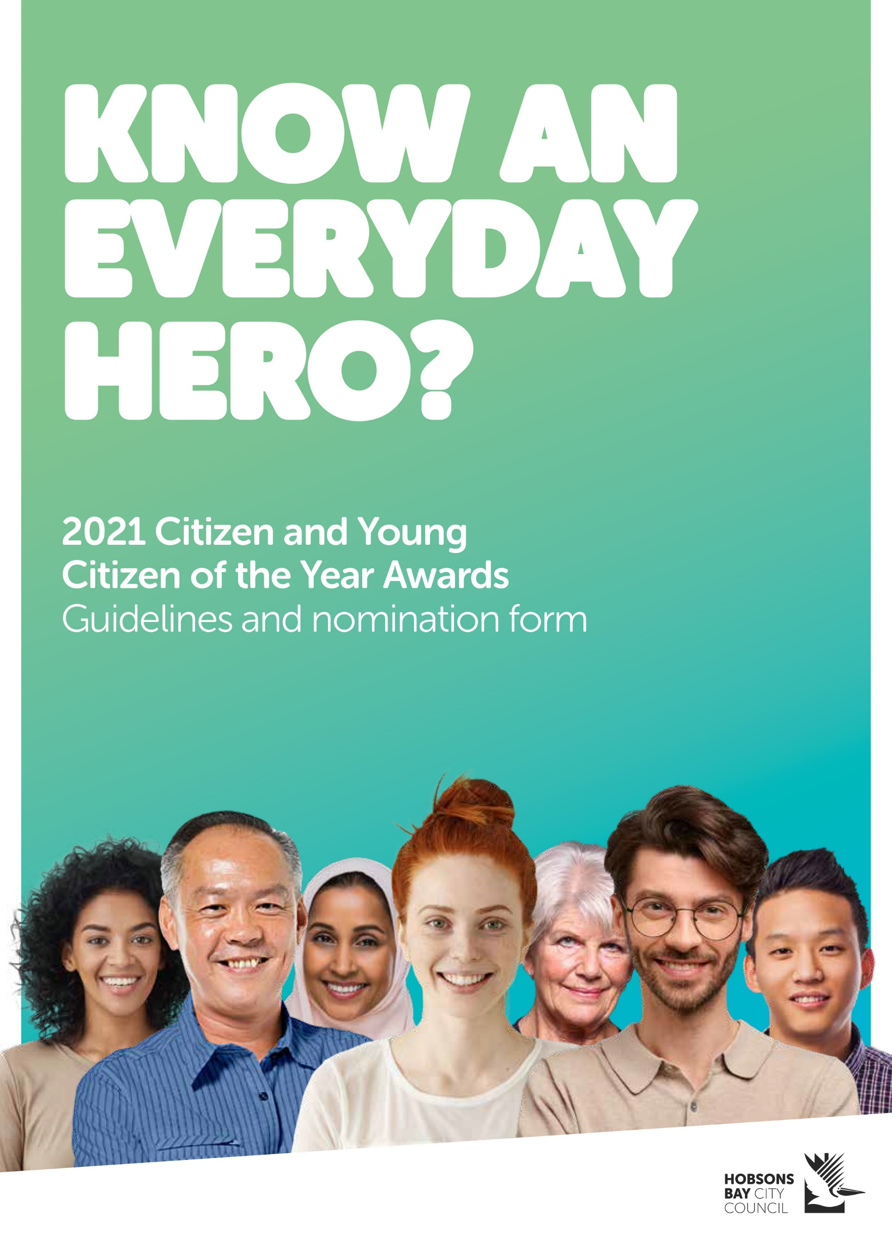

Guidelines
The Hobsons Bay Citizen and Young Citizen of the Year Awards are open to individuals who live, work or study in Hobsons Bay. Awards are presented to a Citizen and Young Citizen of the Year based on their achievements or contributions to the Hobsons Bay community in one or more of the following areas:
- community service
- sport
- arts and culture
- environment
- business and economic development

Criteria and eligibility
To be eligible, nominees must be Australian citizens who live, work or volunteer in Hobsons Bay. Hobsons Bay City Council staff members and Councillors are not eligible to be nominated or to nominate. Nominations from previous recipients or nominees of other Council awards are welcome.
Achievements or contributions that form the basis of nominations must have:
- taken place in the 12 months preceding the nomination date; or
- culminated from many years of work including the 12 months preceding the nomination date.

Nominees for Young Citizen of the Year must be 26 years or younger on 26 January 2021 and nominees for Citizen of the Year must be 27 years or older on 26 January 2021.
The award recipients in each category must be willing to undergo a Victoria Police criminal records check (paid for by Council).

Selection committee

The Selection Committee will comprise the Mayor, Deputy Mayor and the most recent recipients of the Hobsons Bay Citizen and Young Citizen of the Year (or if those persons are unavailable then the next most recent recipient in each category).

Announcement of winners
Award recipients will be announced at the Australia Day citizenship ceremony on 26 January 2021 and their details published on Council’s website www.hobsonsbay.vic.gov.au and social media channels.

How to nominate
Please complete this form and send to:
Citizen of the Year Awards
Communications, Engagement and Advocacy Unit
Hobsons Bay City Council
PO Box 21, Altona 3018

Or complete an online nomination form at www.hobsonsbay.vic.gov.au/citizenawards

Nominations close at 5pm Friday 18 December 2020. For more information, please call the Communications Team on 1300 179 944.
Nomination form
I/we wish to nominate the following person for:
Citizen of the Year Young Citizen of the Year

Nominee details
Title:
Name:
Street address:
Suburb: |  | Postcode:
Phone (business hours): |  | Mobile:
Email:
Age as at 26 January 2021 (For Young Citizen of the Year nominees):

Summary of supporting nomination

Briefly explain the nominee’s achievements and how the community of Hobsons Bay has benefitted from their actions (maximum 600 words). Attach additional paper if needed.

Nominee background
Please provide any other relevant information or details to support the nomination. You may attach clear copies of any newspaper articles, photographs or other relevant information (such as awards) about the nominee and their achievements.

Is the nominee aware of the nomination? Yes No

Would you like a representative from Council to call you for further information?

Yes No

References

Please provide details of one other person who can support this nomination.
Referee details
Name:
Position:
Street address:
Suburb: |  | Postcode:
Phone (business hours): |  | Phone (after hours):
Relationship to nominee:
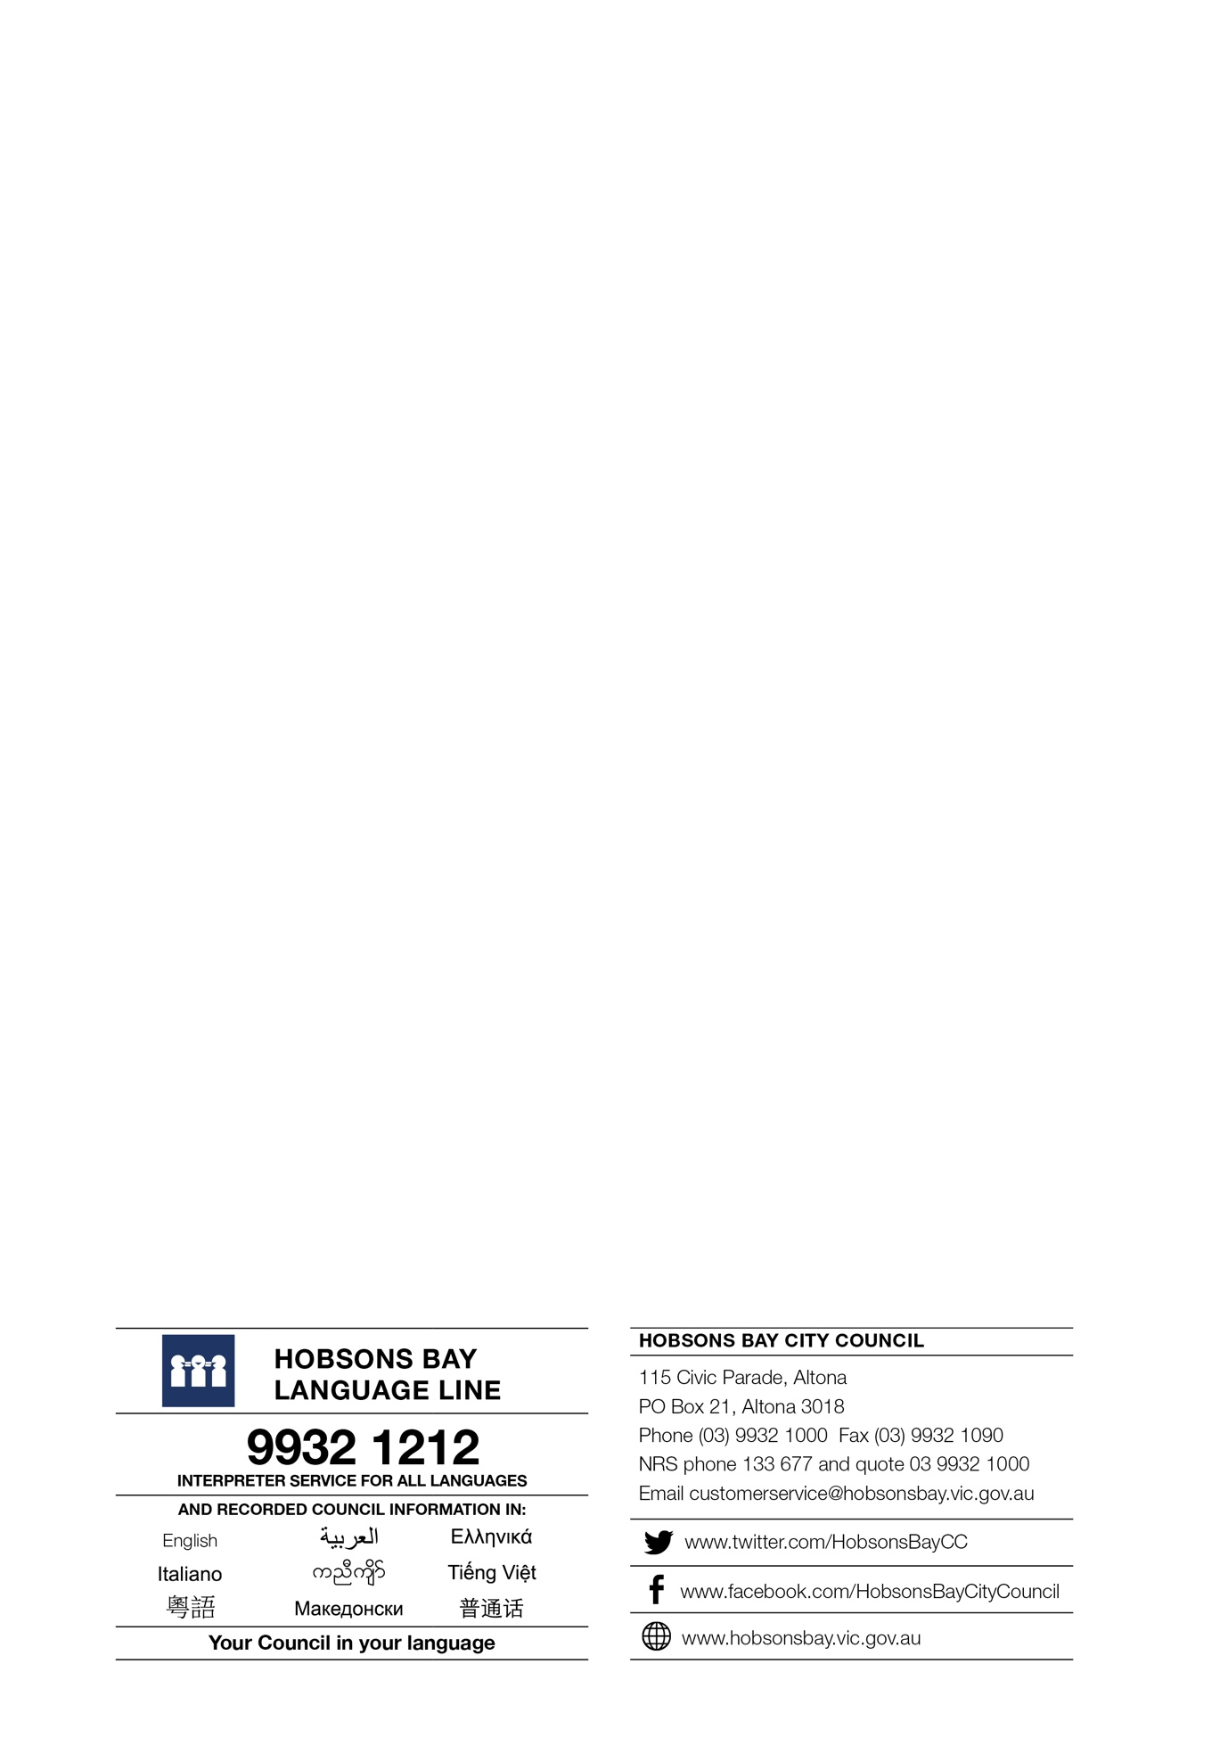
Details of person submitting nomination
Name:
Street address:
Suburb: |  |  | Postcode:
Phone (business hours): |  |  | Mobile:
Email:
How did you hear about the awards?

Privacy Collection Statement
In accordance with the Information Privacy Act 2000, the personal information collected on this form is for the purpose of processing and considering award nominations. It will not be used for any other purpose, or provided to any other parties.

